

**UNIVERSITI MALAYSIA TERENGGANU**

**CSM 3103 PROGRAMMING FRONT-END**

**BACHELOR OF COMPUTER SCIENCE (MOBILE COMPUTING)**

**LAB 4**

**SEMESTER II 2023/2024**

**PREPARED FOR:**

**DR. RABIEL BIN MAMAT**

**PREPARED BY:**

**NUR IZZATI NAJWA BINTI MOHD BAKHRI (S65417)**

**Task 1 – JavaScript Function**

1. Write a function to find the square of a given number

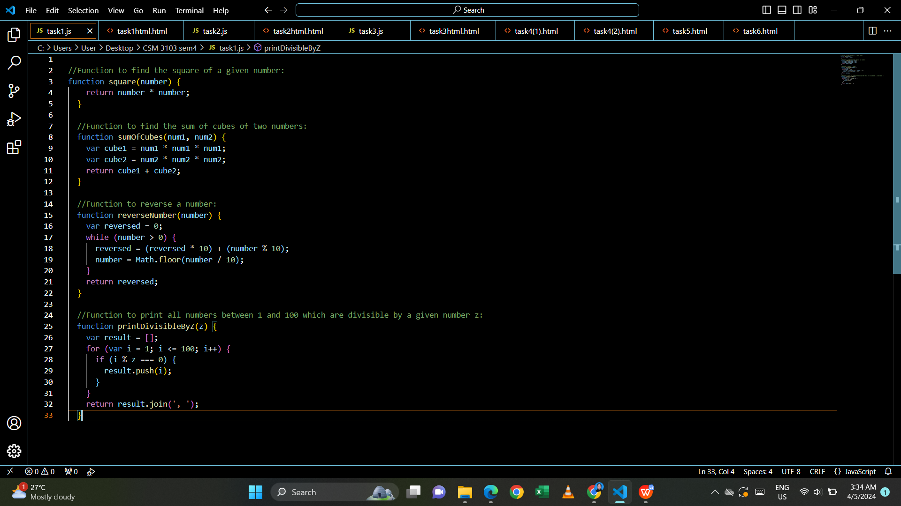

1. Write a function to find sum of cubes of two numbers



3. Write a function to reverse a number

[ Hint n =12345 output : 54321 ]



4. Write a function to print all numbers between 1 and 100 which is divisible by

given number z



Html code:

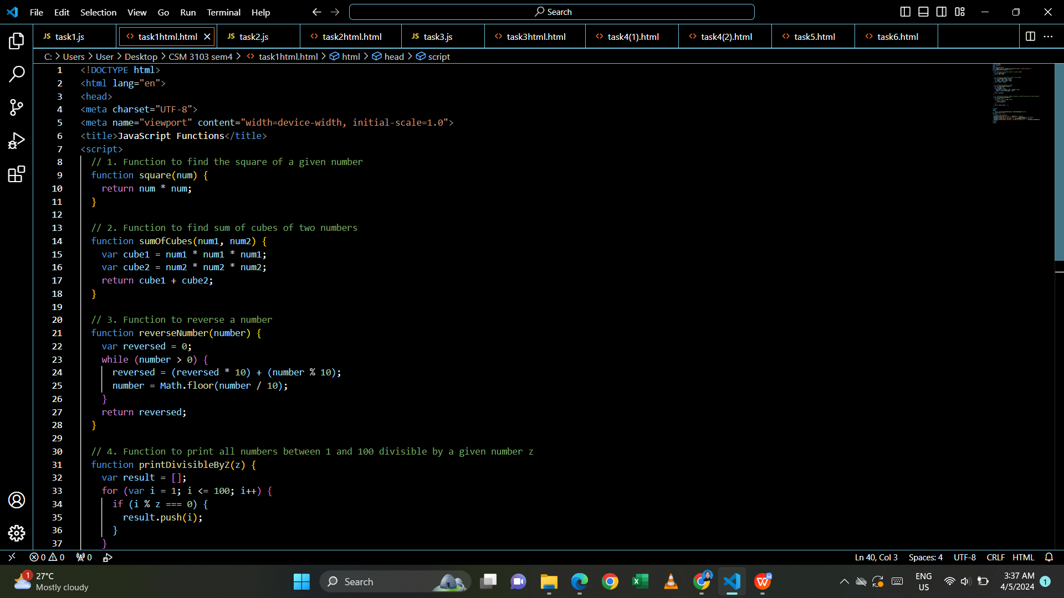

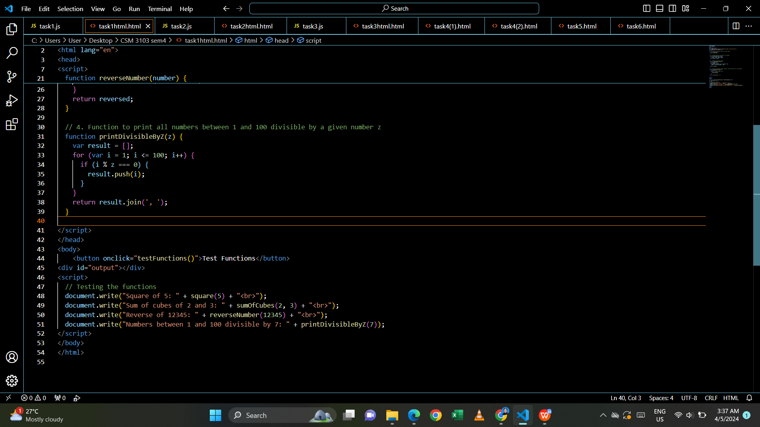

Output:

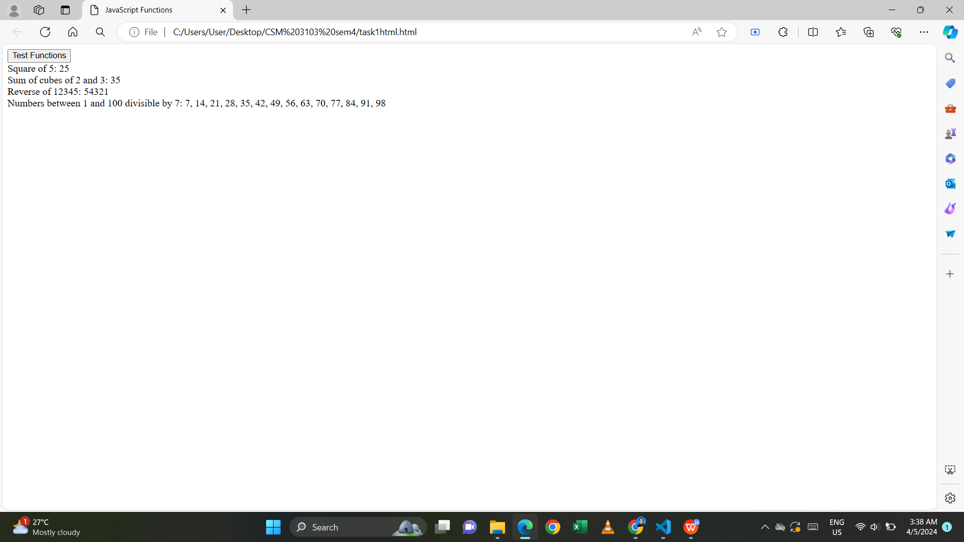

**Task 2 - JavaScript Recursion Function**

1. Write a JavaScript function to find sum of digits of a number

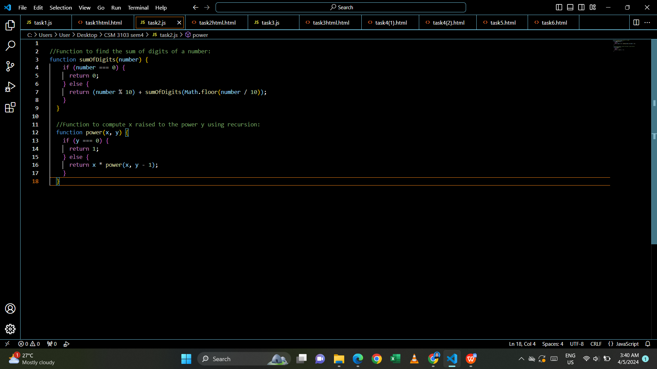

1. Write a JavaScript program to compute x raise to the power y using recursion



Html code:

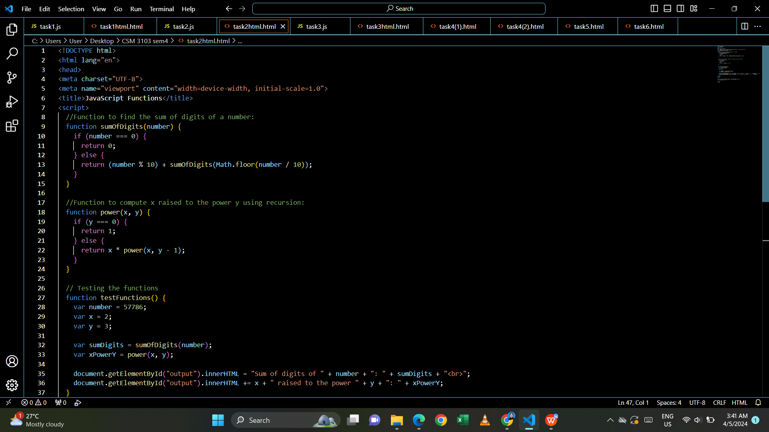

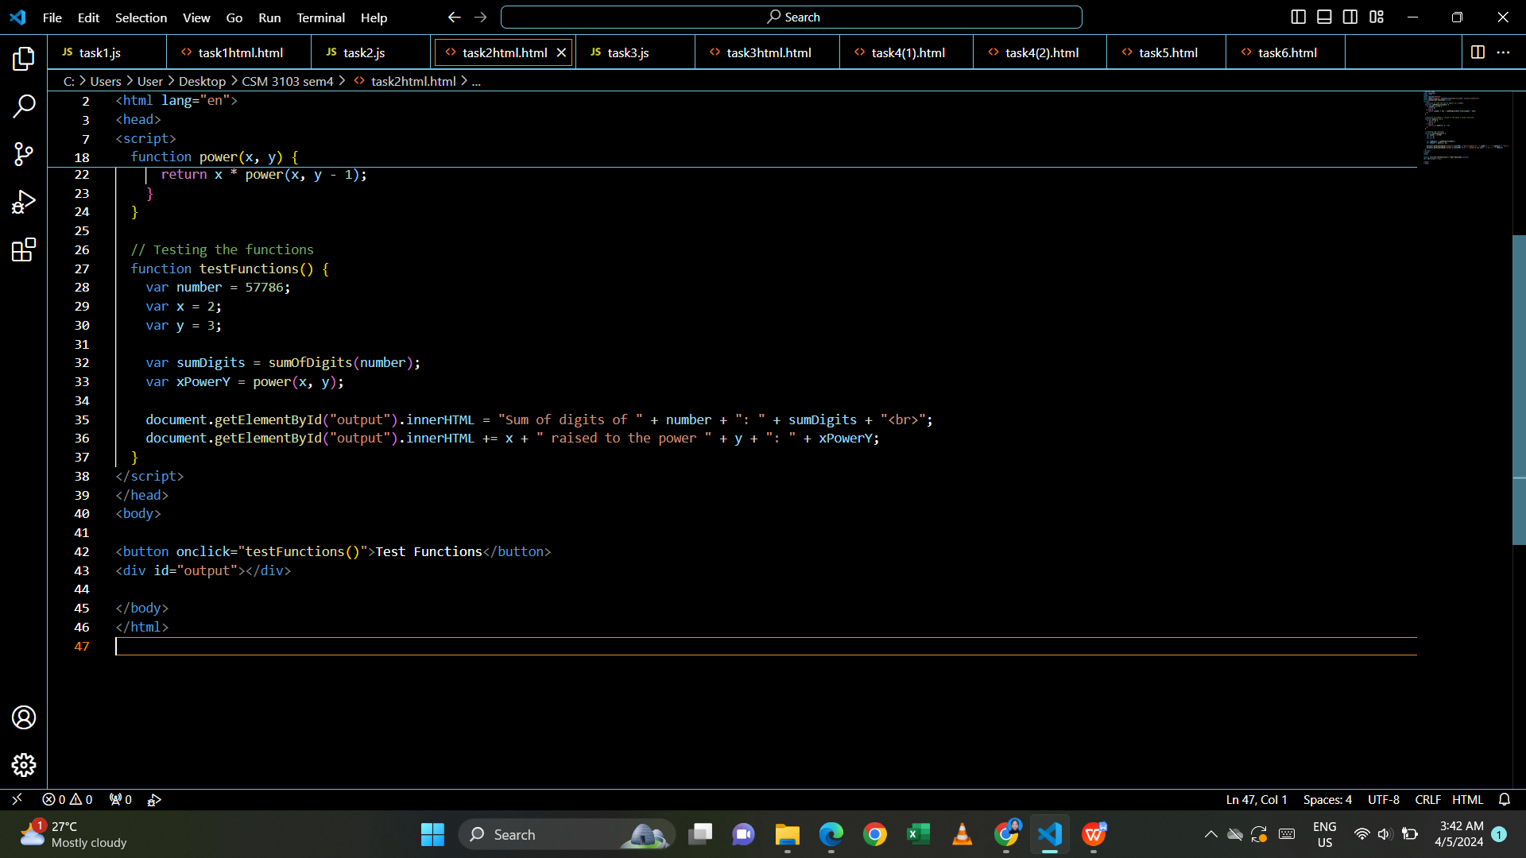

Output:

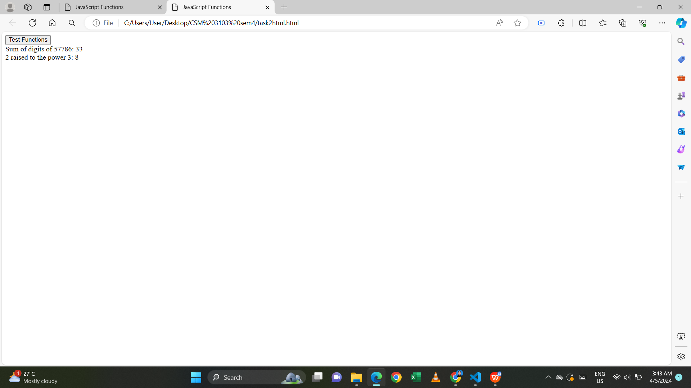

**Task 3 – JavaScript Object and Prototype**

1. Write a JavaScript program to create object product,

1. Add the property Product Name, Quantity and price.
2. Access all the properties and display them.

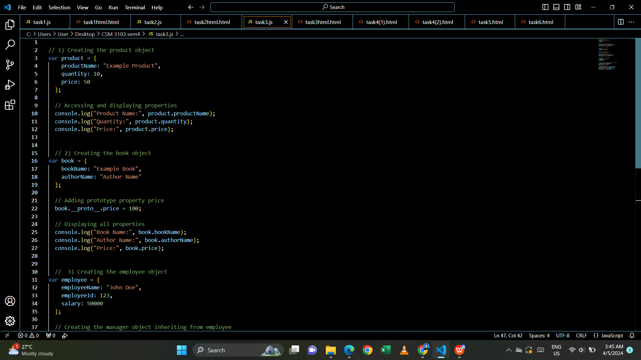

2. Write a JavaScript program to create object book

1. Add the property book name, author name
2. Add the prototype property price .
3. Display all the properties.



3. Write a JavaScript program to create Parent object employee (Property :

Employee Name , Employee Id , Salary) and Child object Manager (Property :

Manager Name , Branch). Inherit all the properties of employee and display all

the properties.

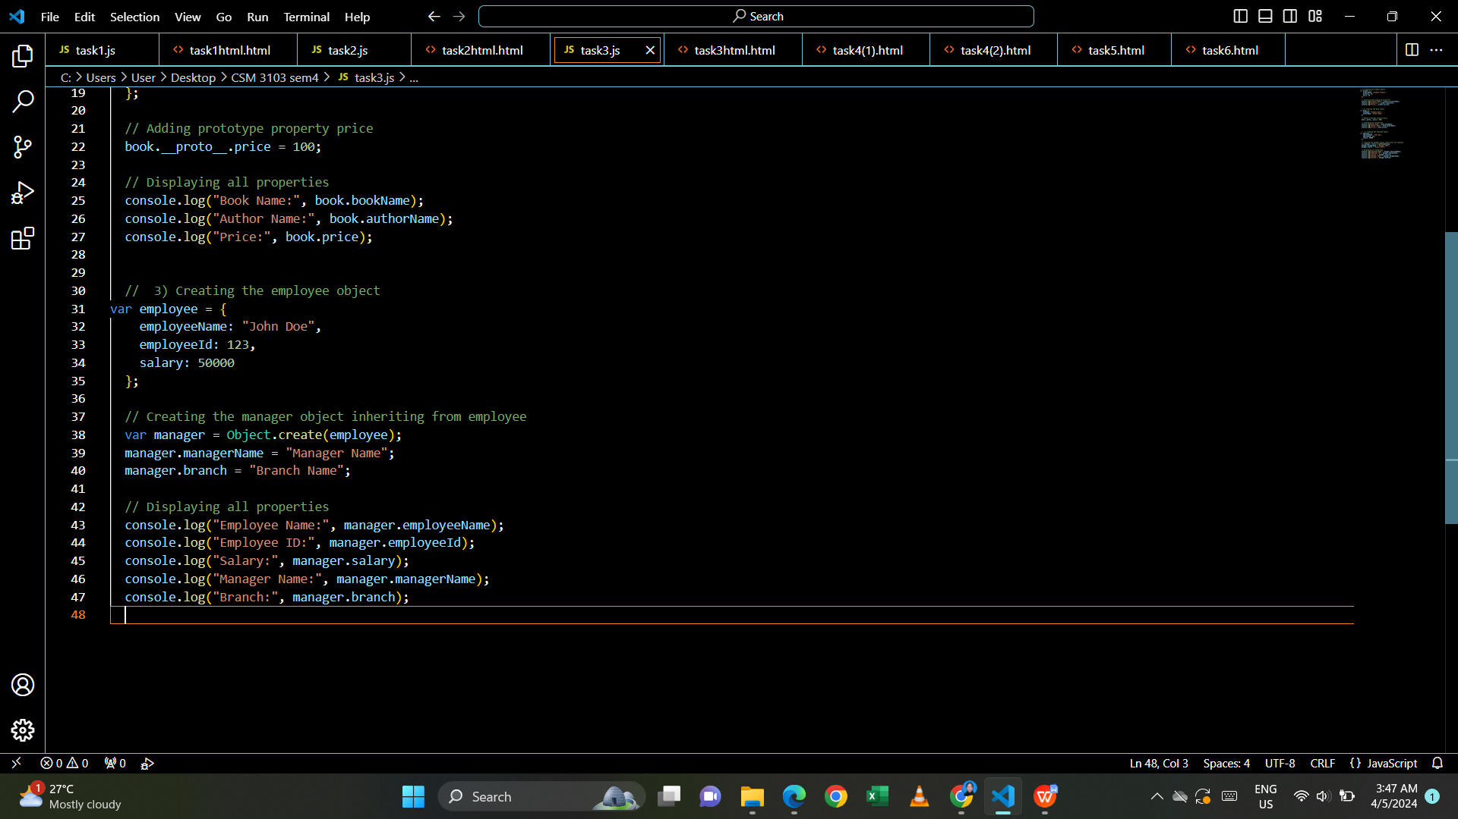

Html code:

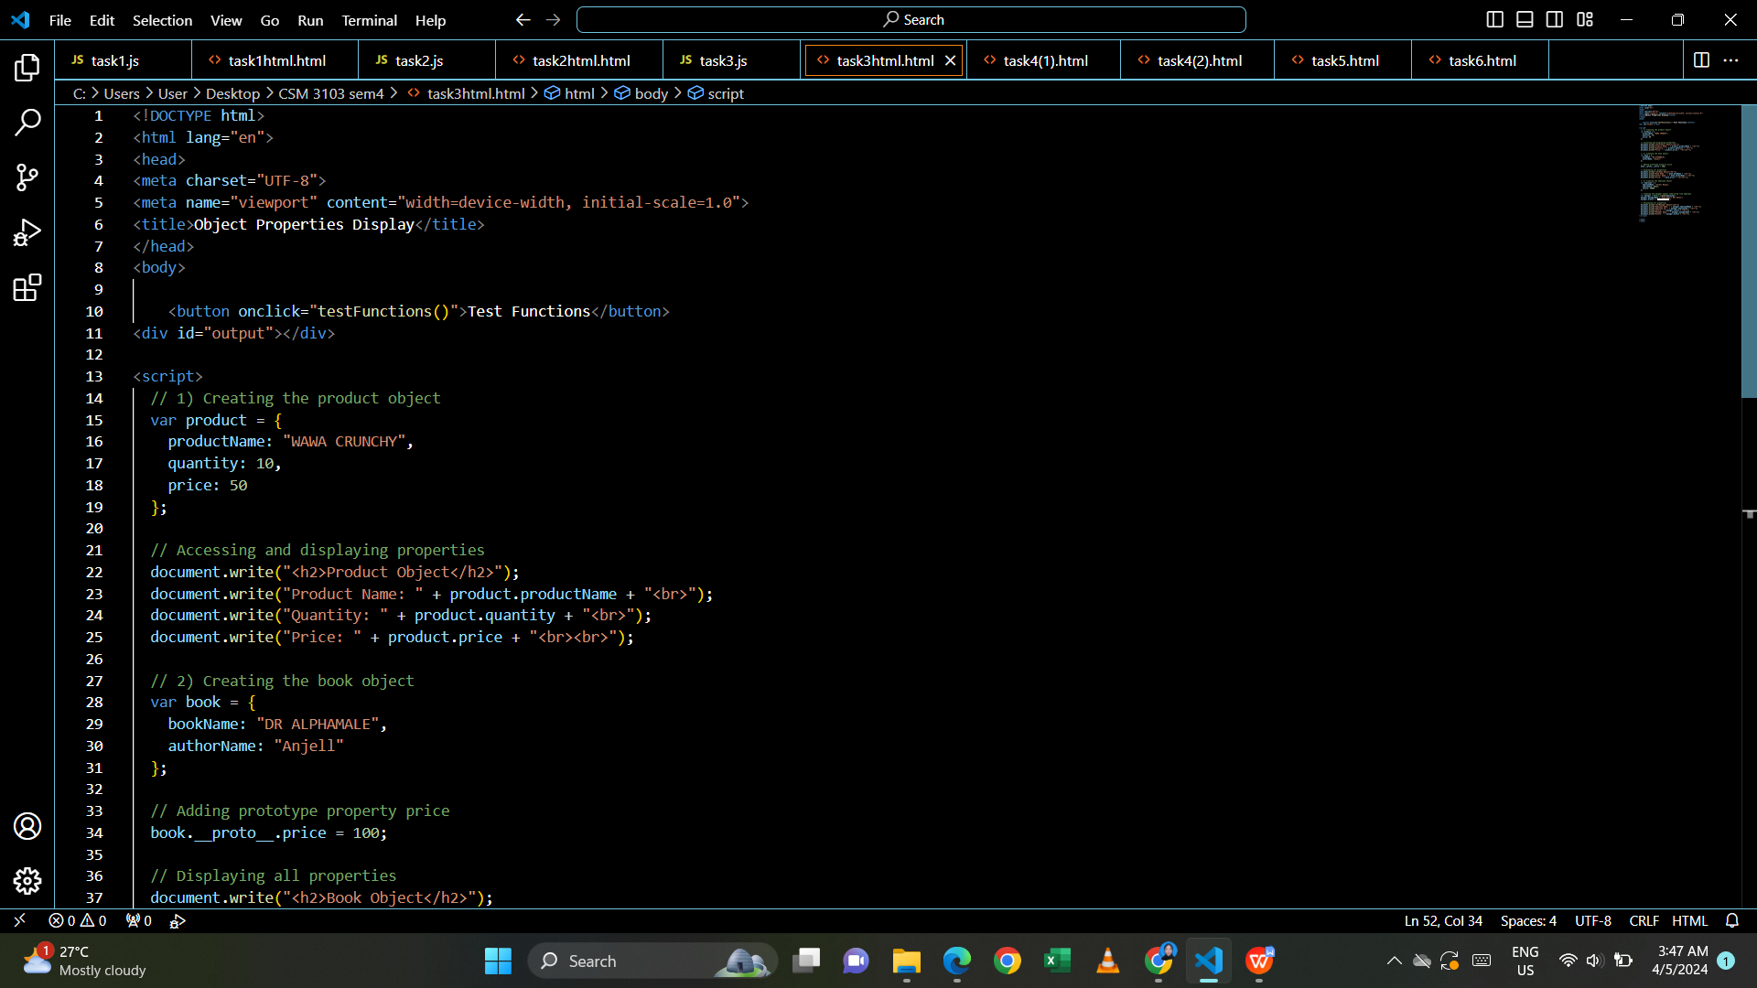

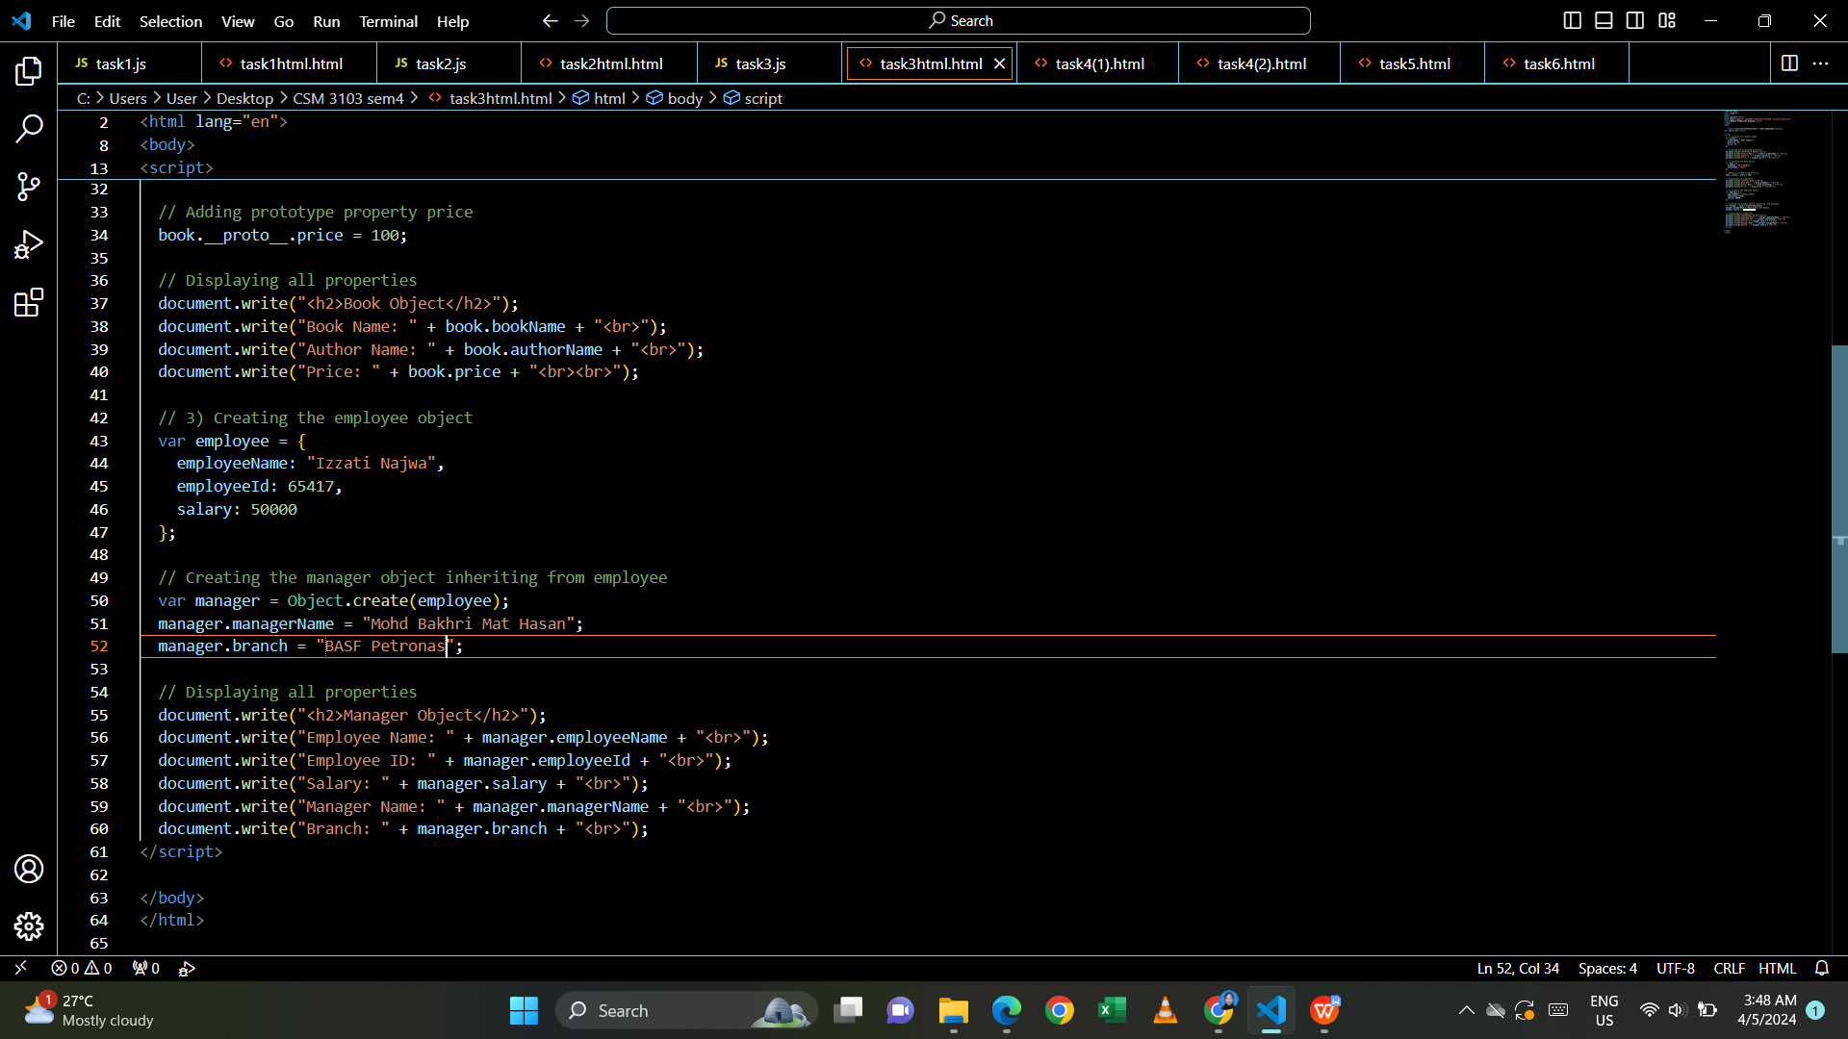

Output:

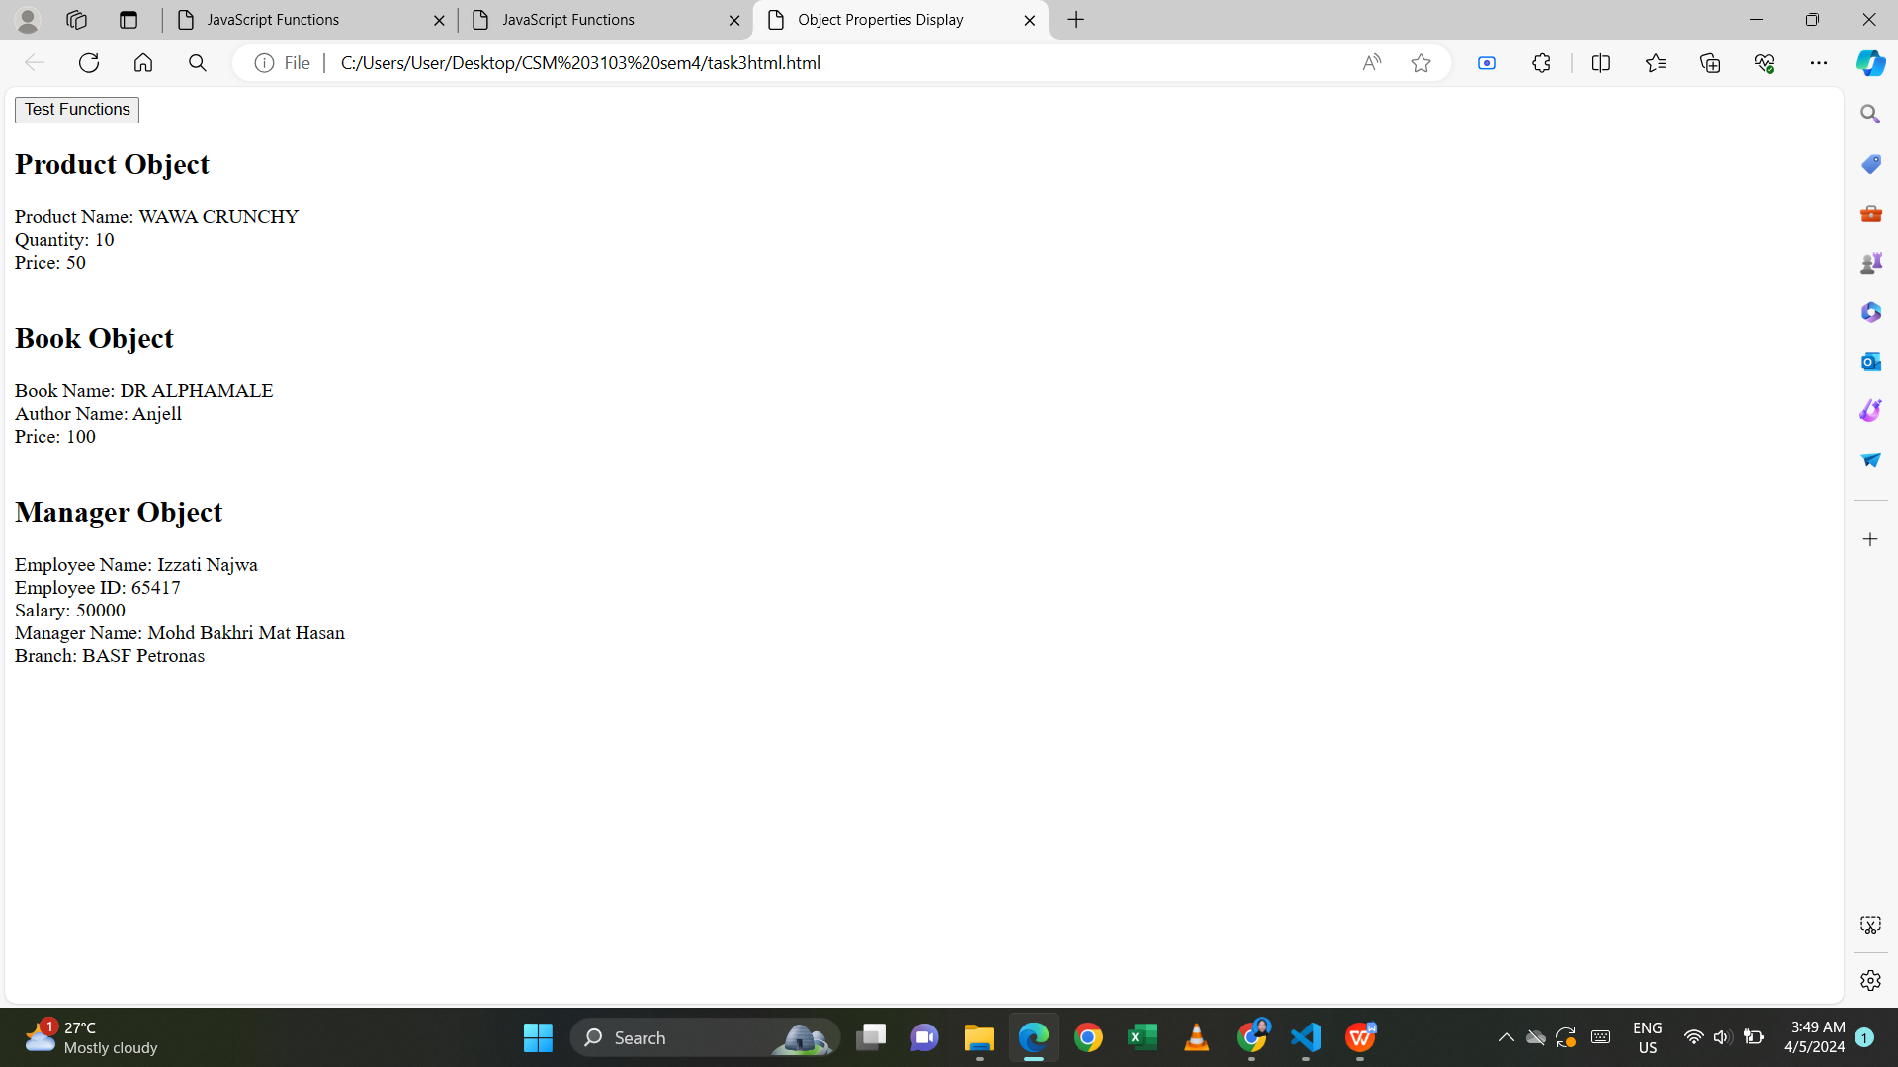

**Task 4 – Event Manager**

1. Create a HTML page with <p> paragraph. Change the paragraph color according

to the following mouse events

1. Onclick, yellow background
2. ondblclick, blue background
3. onmouseover , red background
4. onmouseout, green background

Html code:

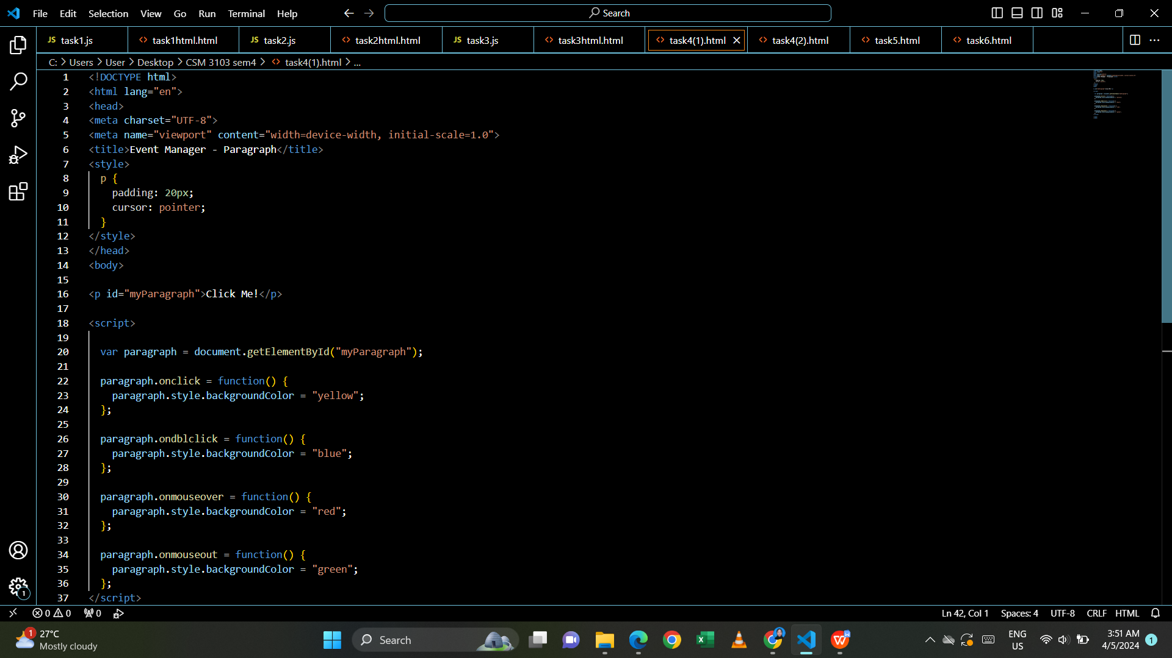

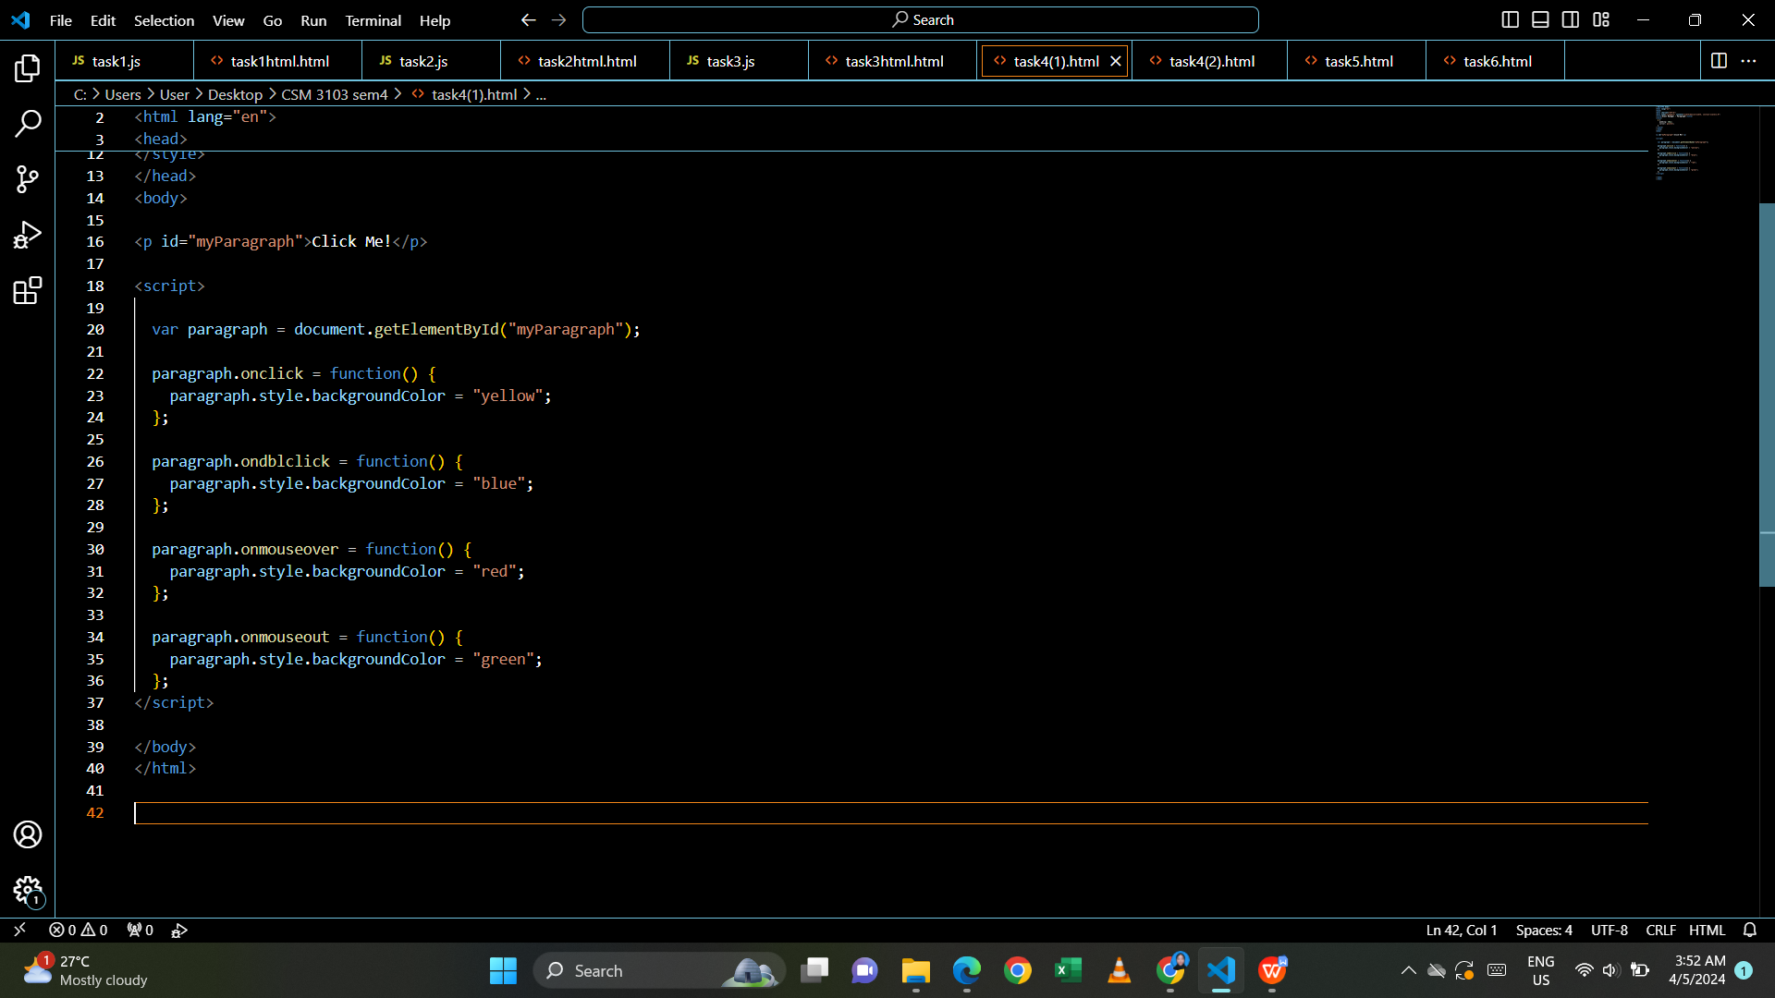

Output:

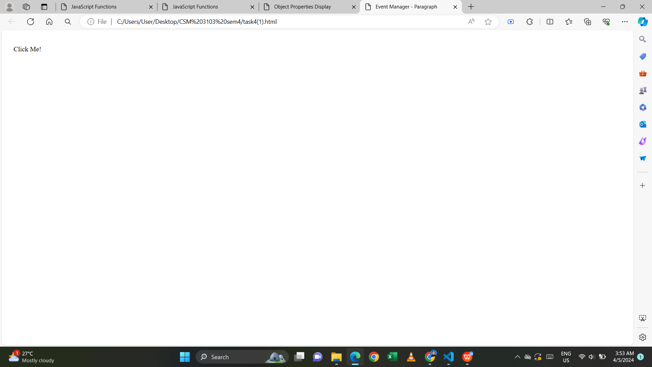

- onmouseover

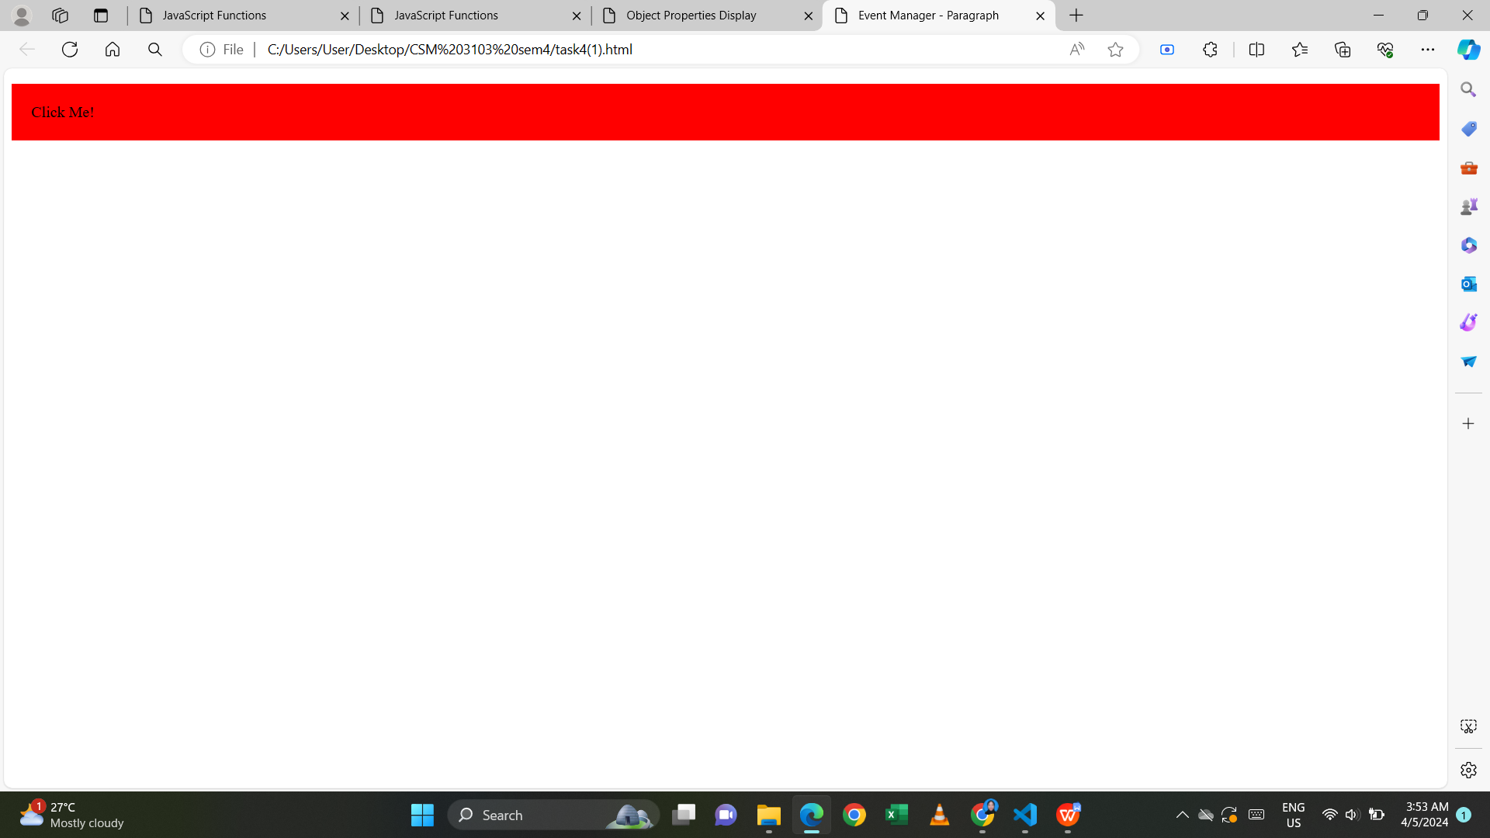

- onmouseout

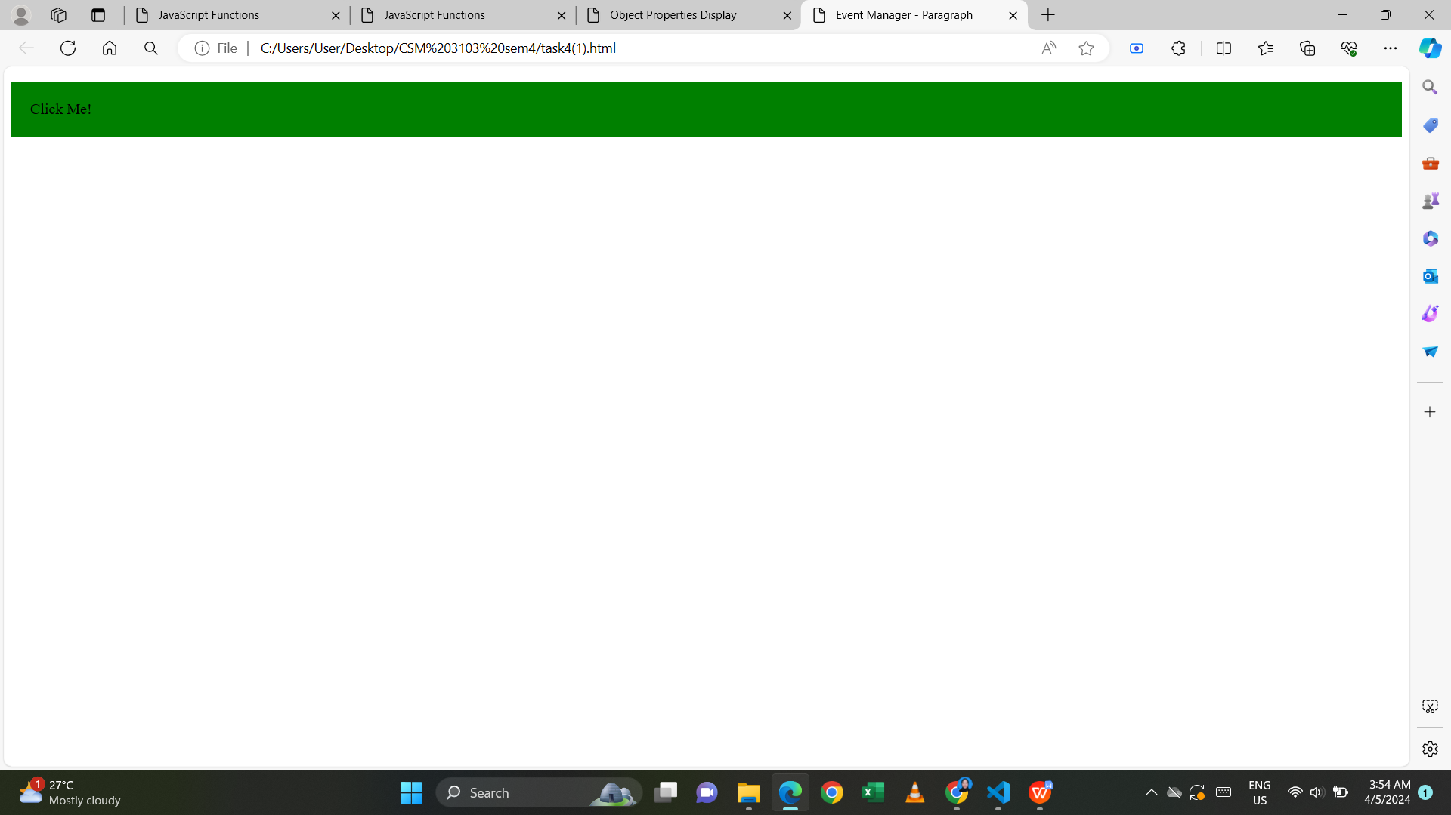

- Onclick

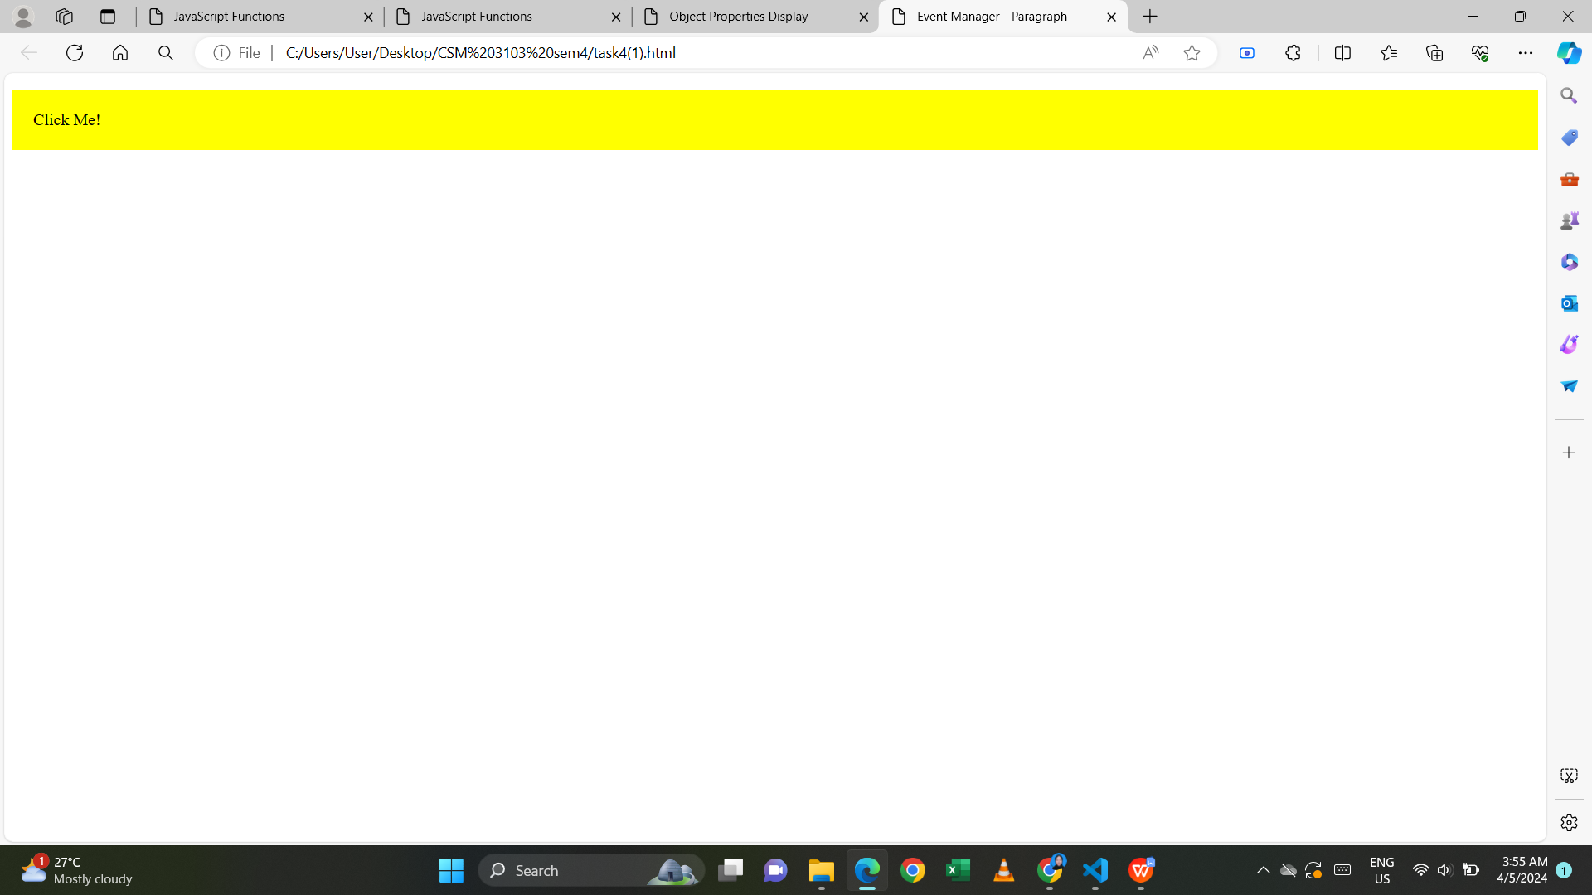

- ondoubleclick

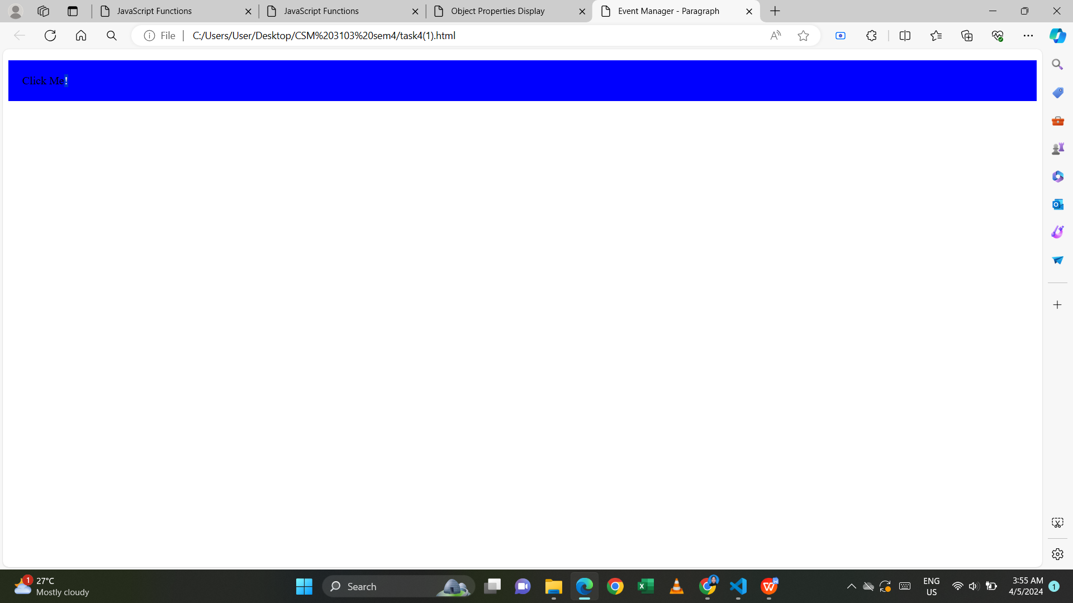

2. Create a HTML page with textfield. Show some effects on the textfield when the

following events occurred:

1. Onchange
2. Onfocus
3. Onblur

Html code:

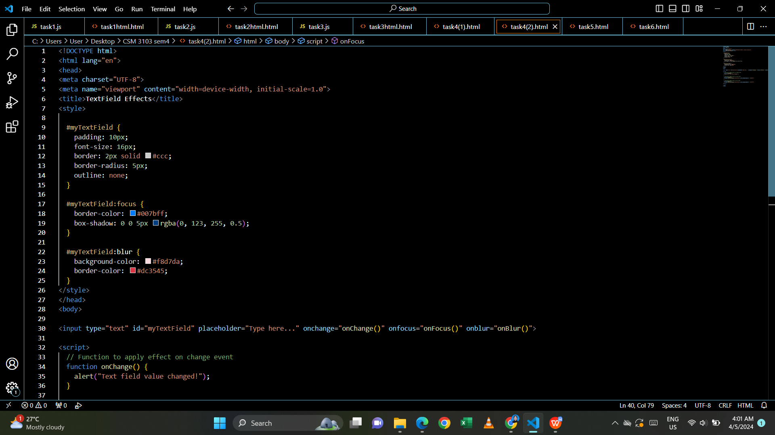

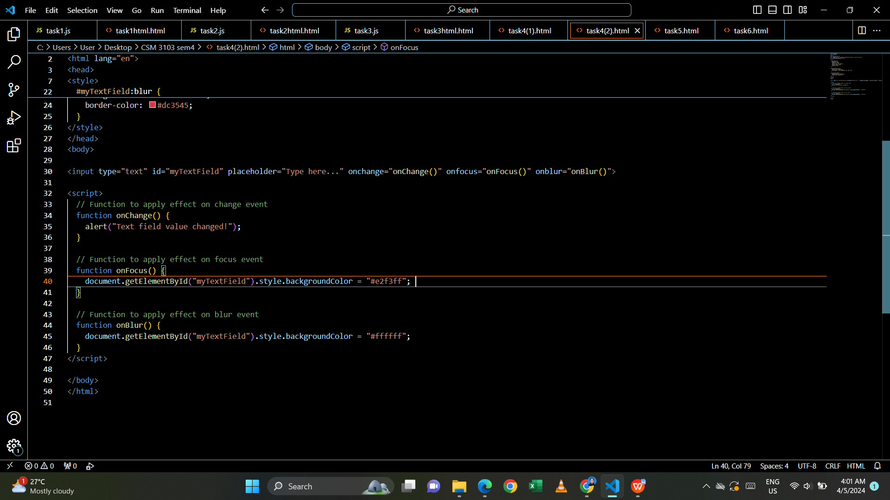

Output:

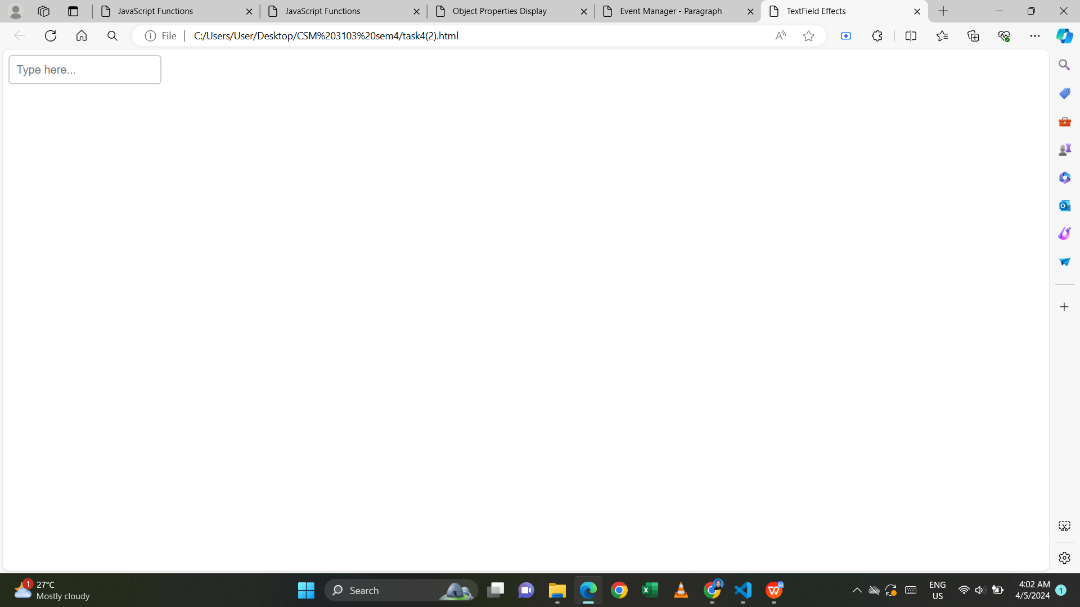

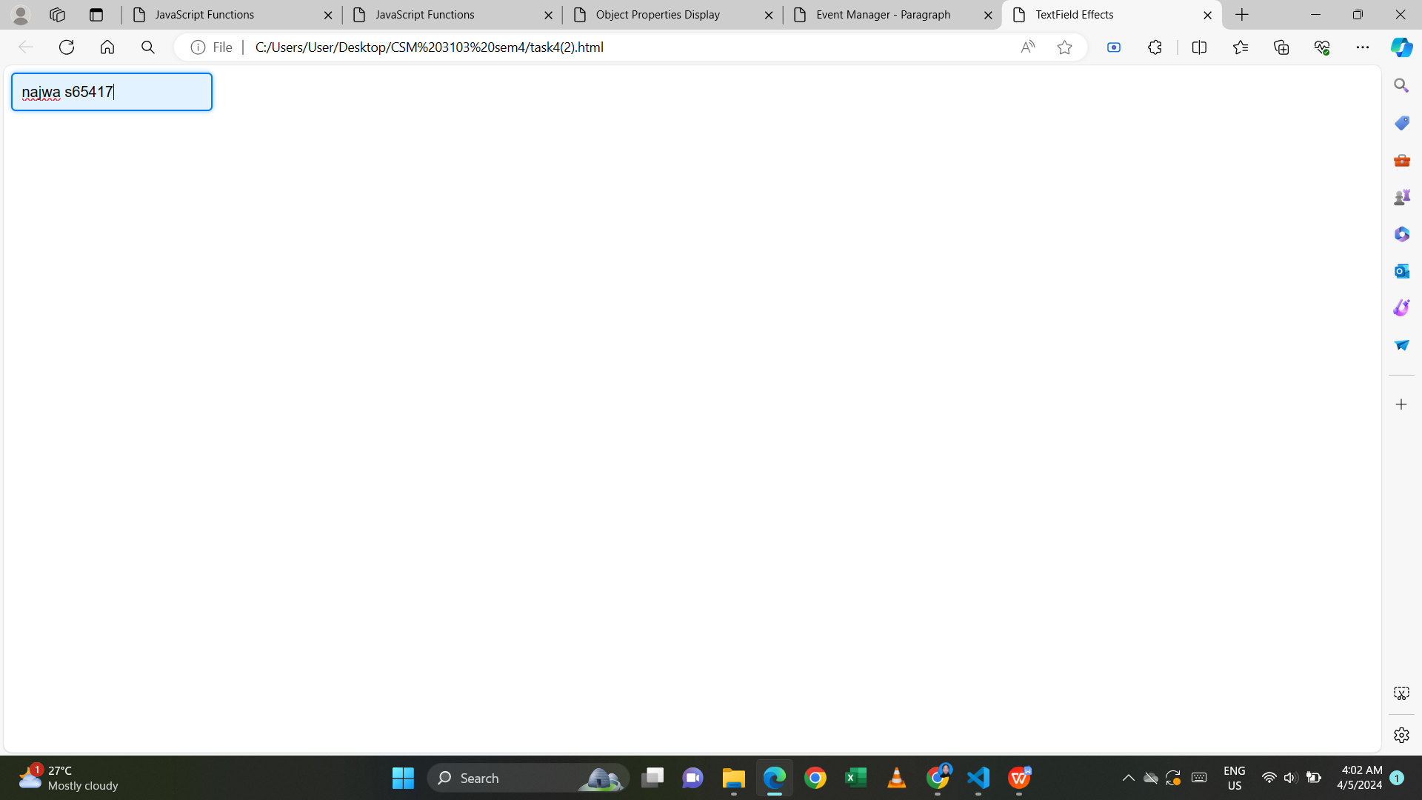

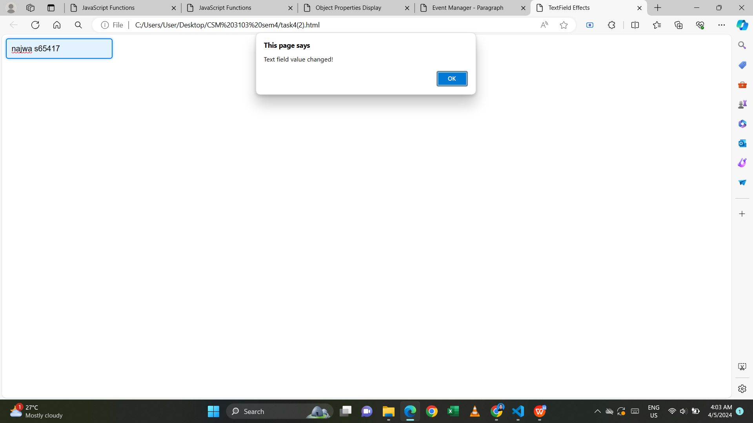

**Task 5**

1. Using javascript add the following record into table

1. Name: Mukhriz Jamil Asoka
2. Email: mukriz@corp.jo
3. Phone: 651181187223
4. Using javascript add the table header as follow:
5. #, Name, Email, Phone #
6. Using javascript, delete any row from table when clicked on that row

Html code:

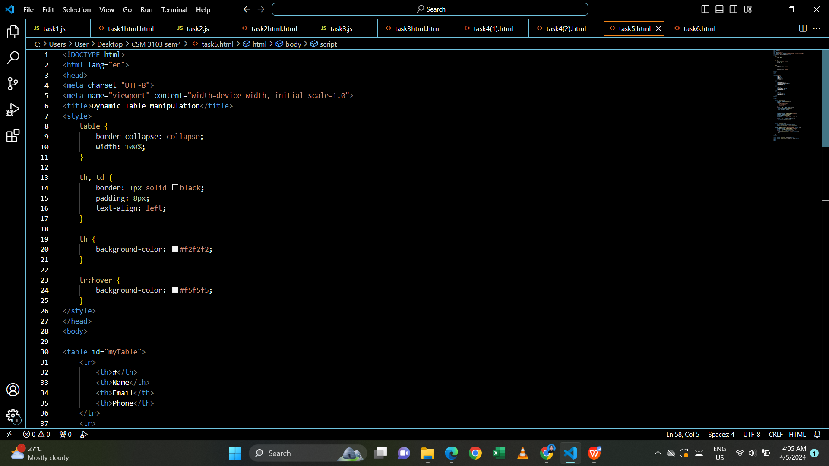

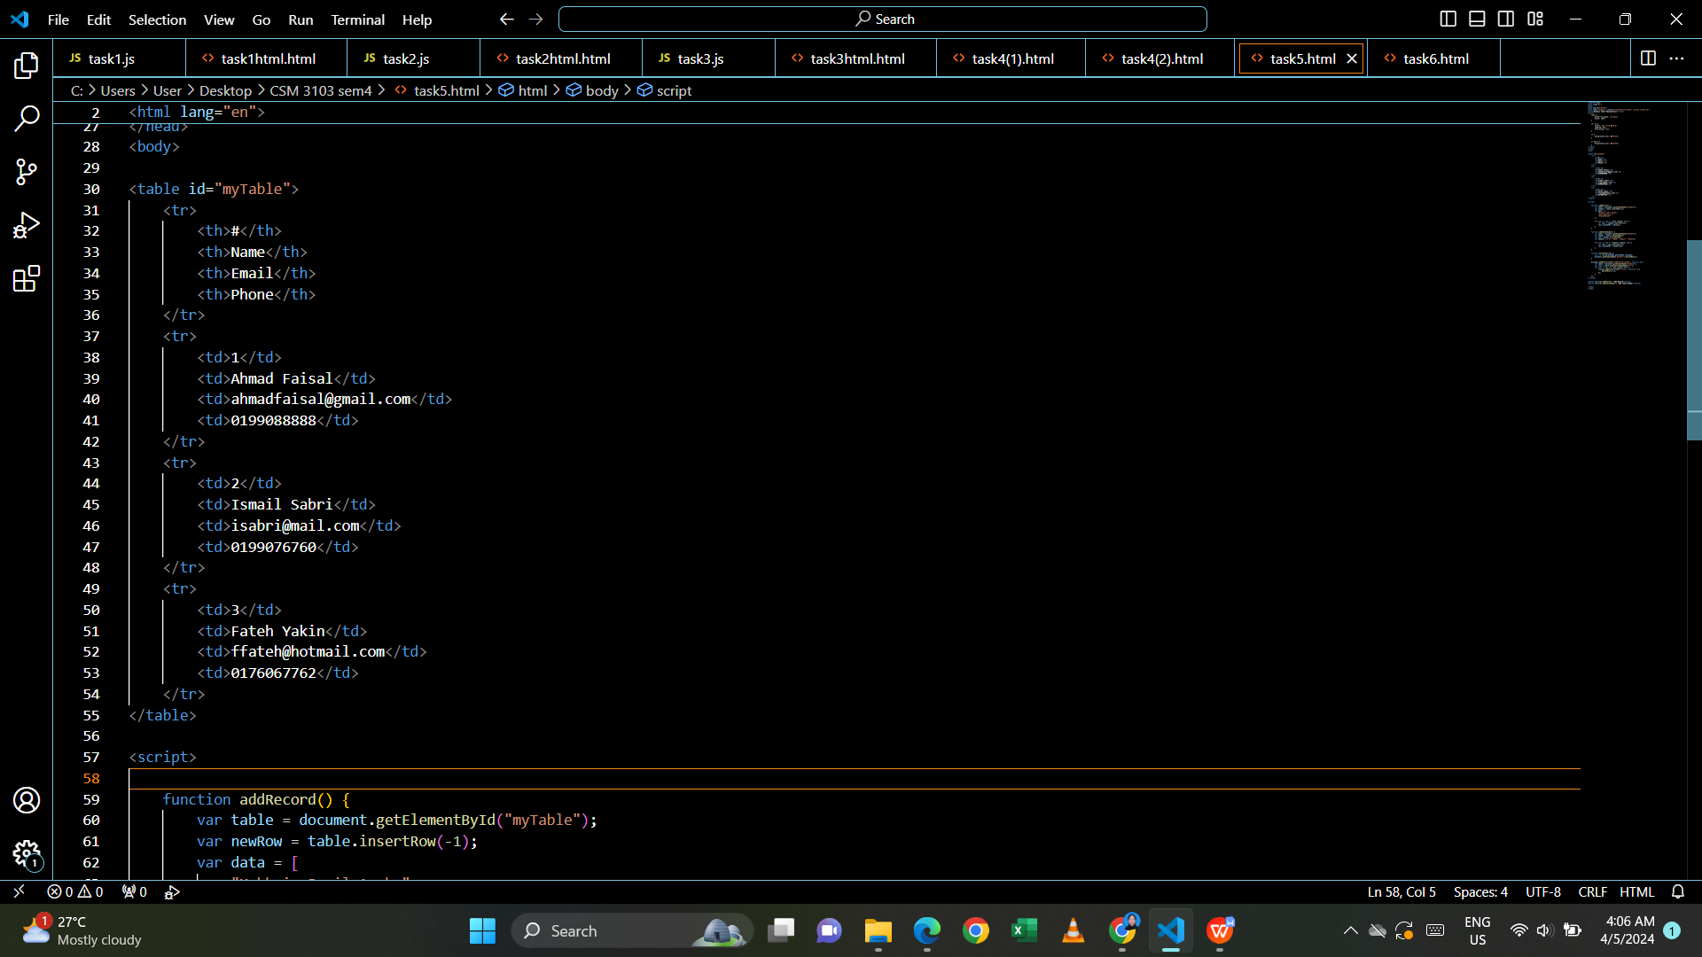

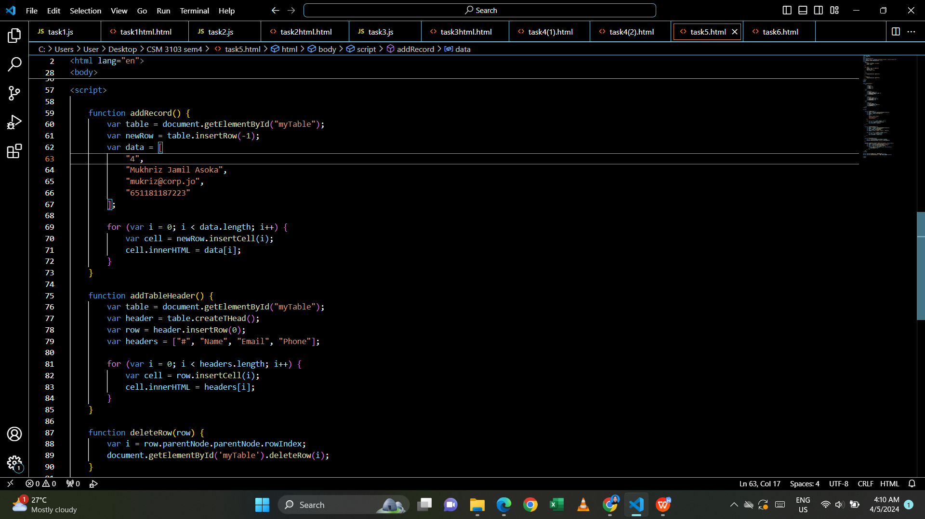

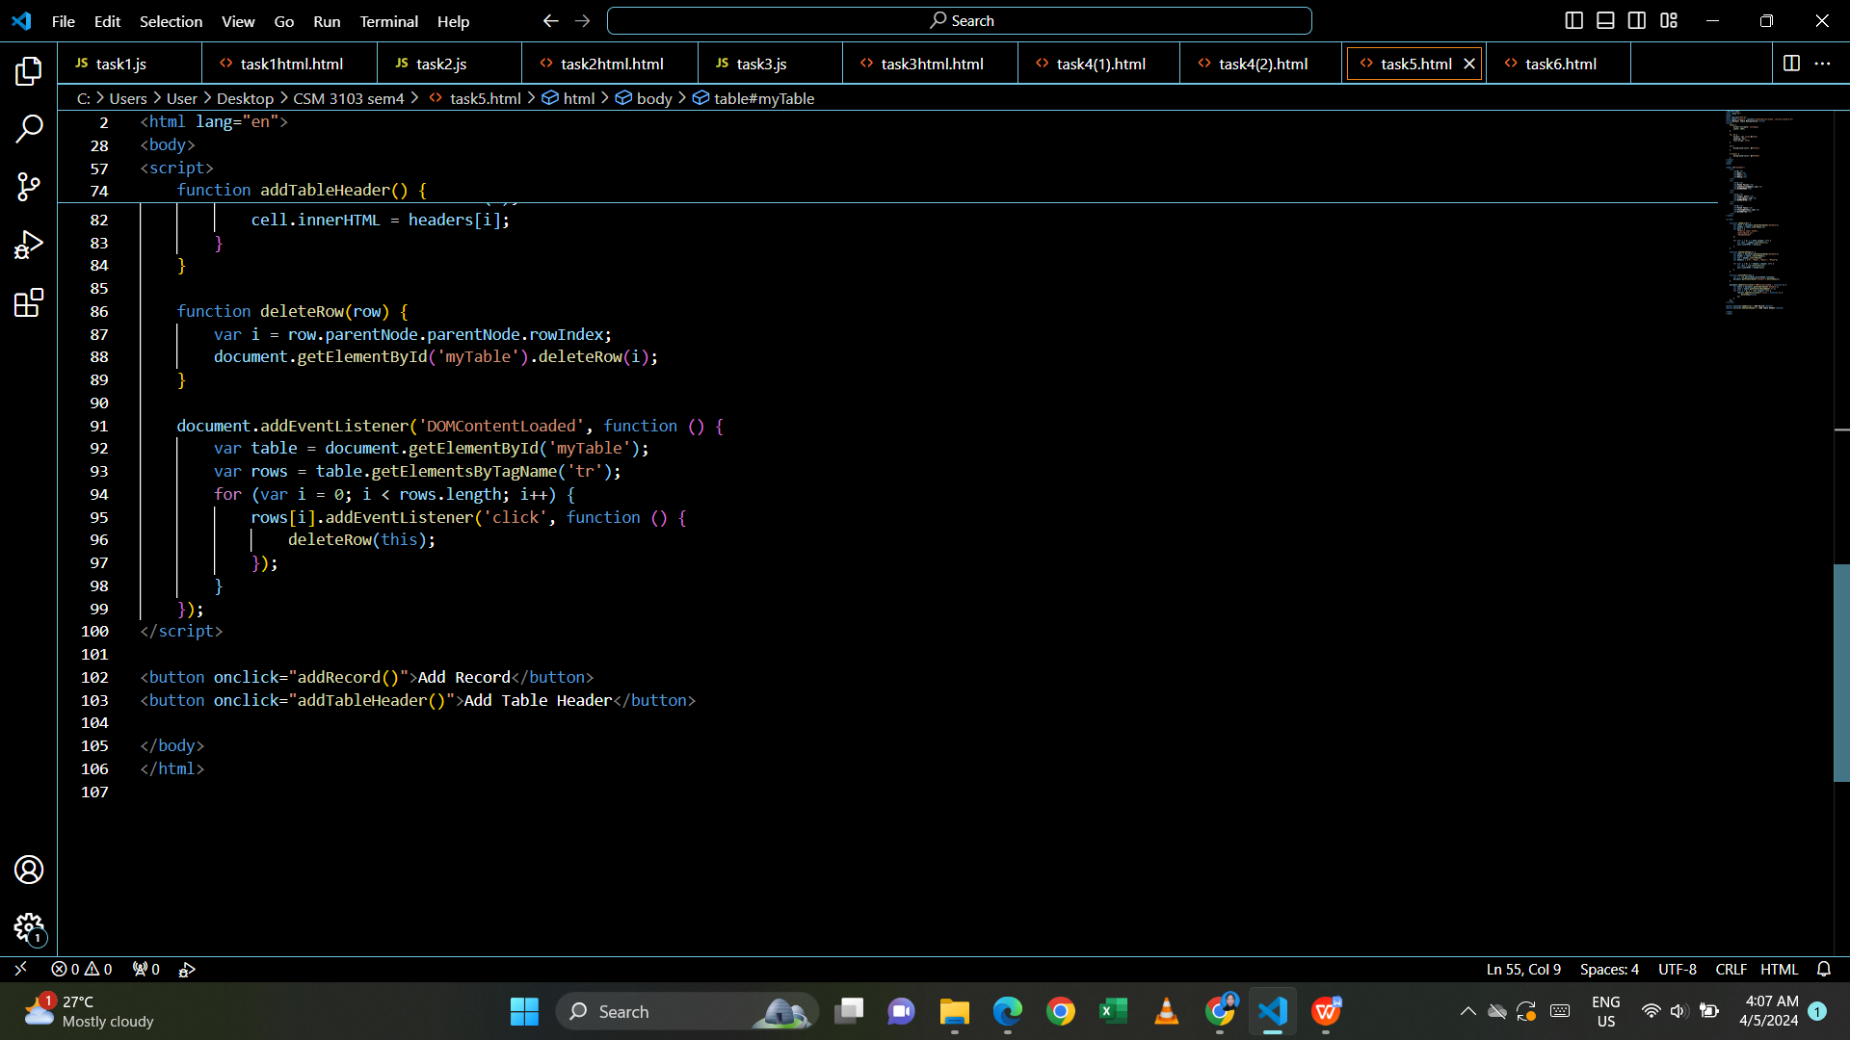

Output:

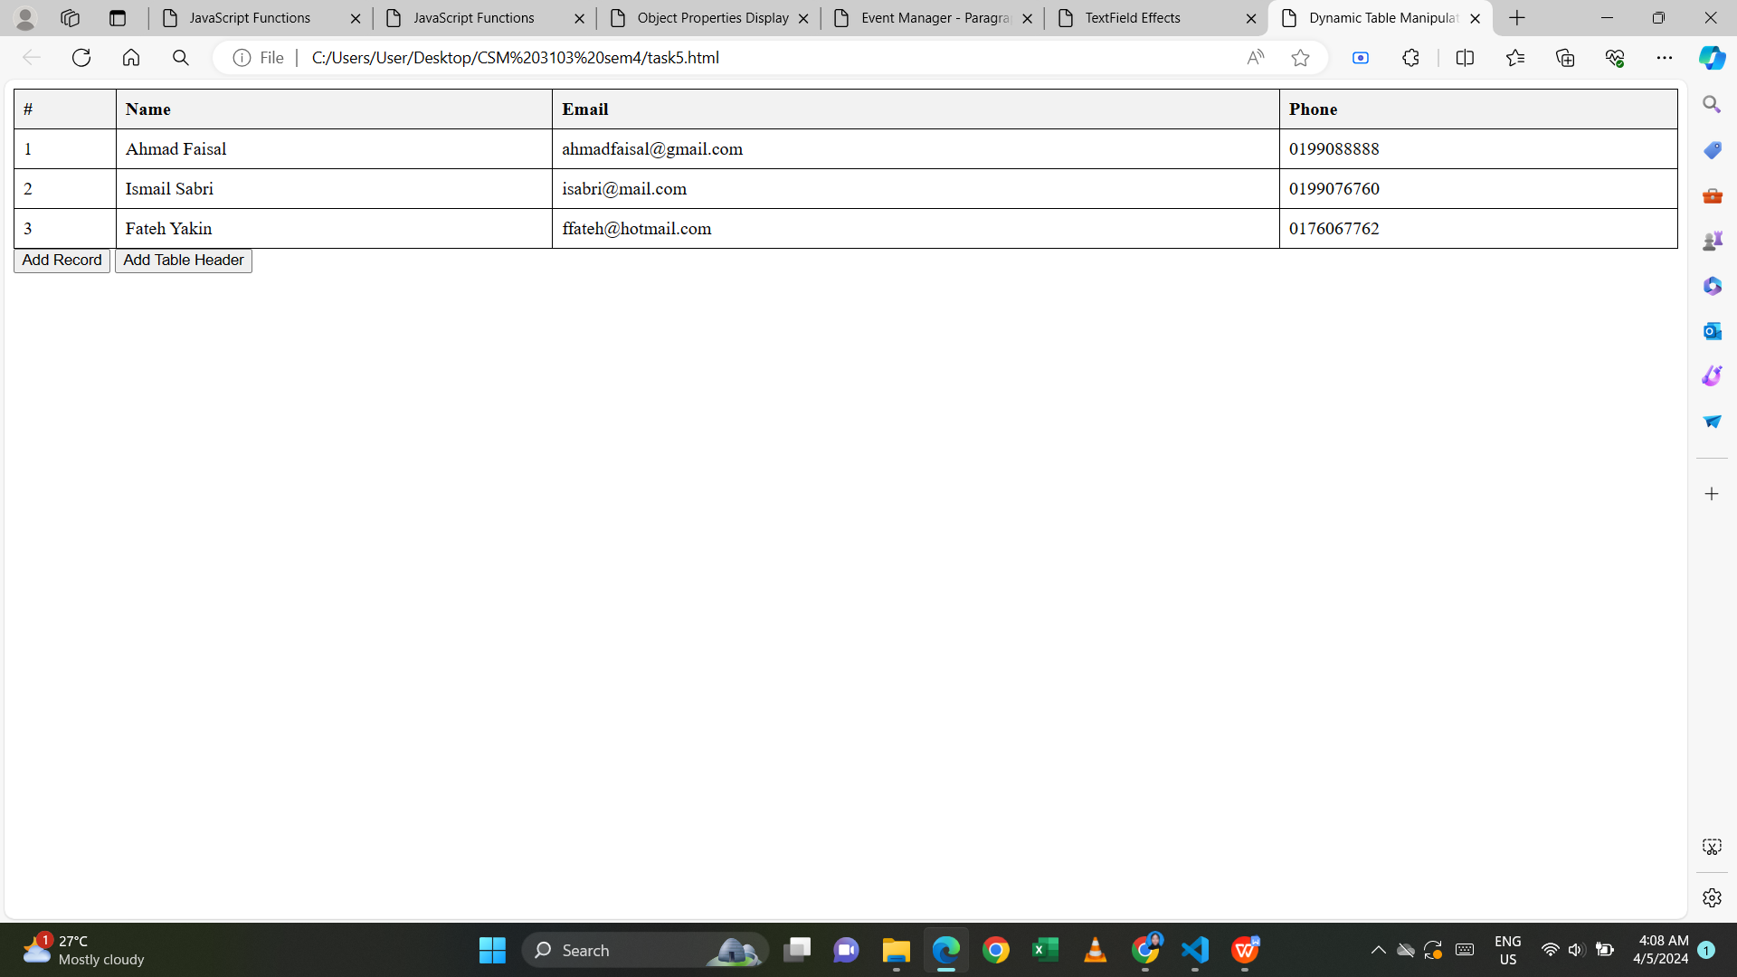

- add record

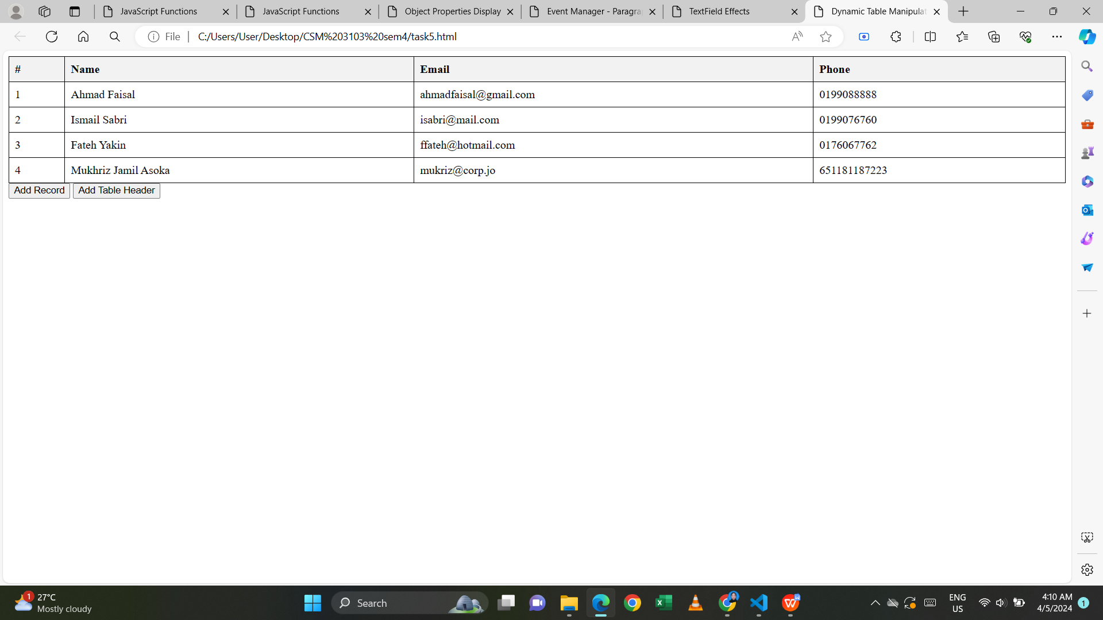

- delete row

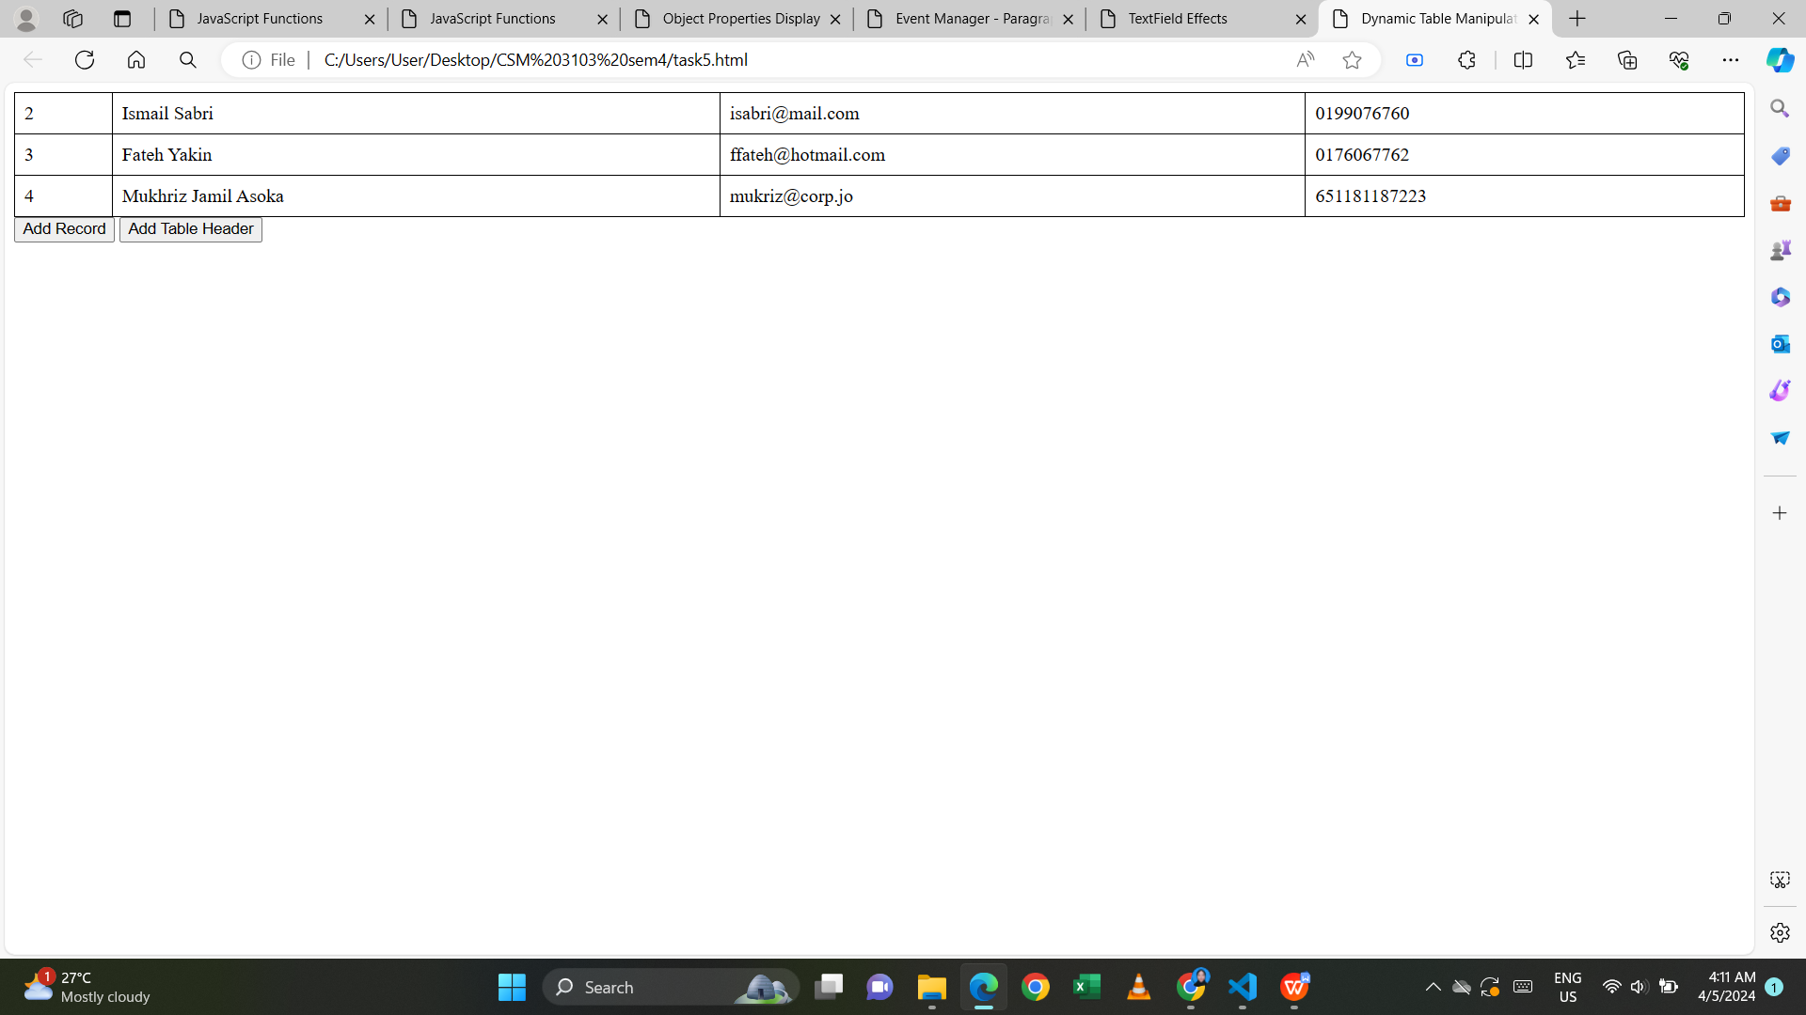

**Task 6**

Write a JavaScript program to move two small squares inside one big square in a random manner. User should be able to start and stop this animation using button based events:

Math.floor(Math.random() * Math.floor(max)) will give you a

random number that is less than max value

Html code:

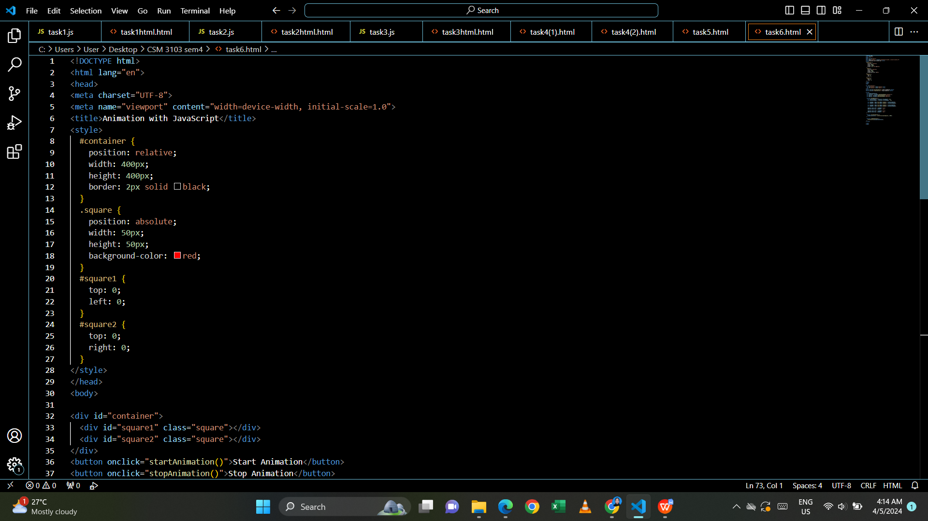

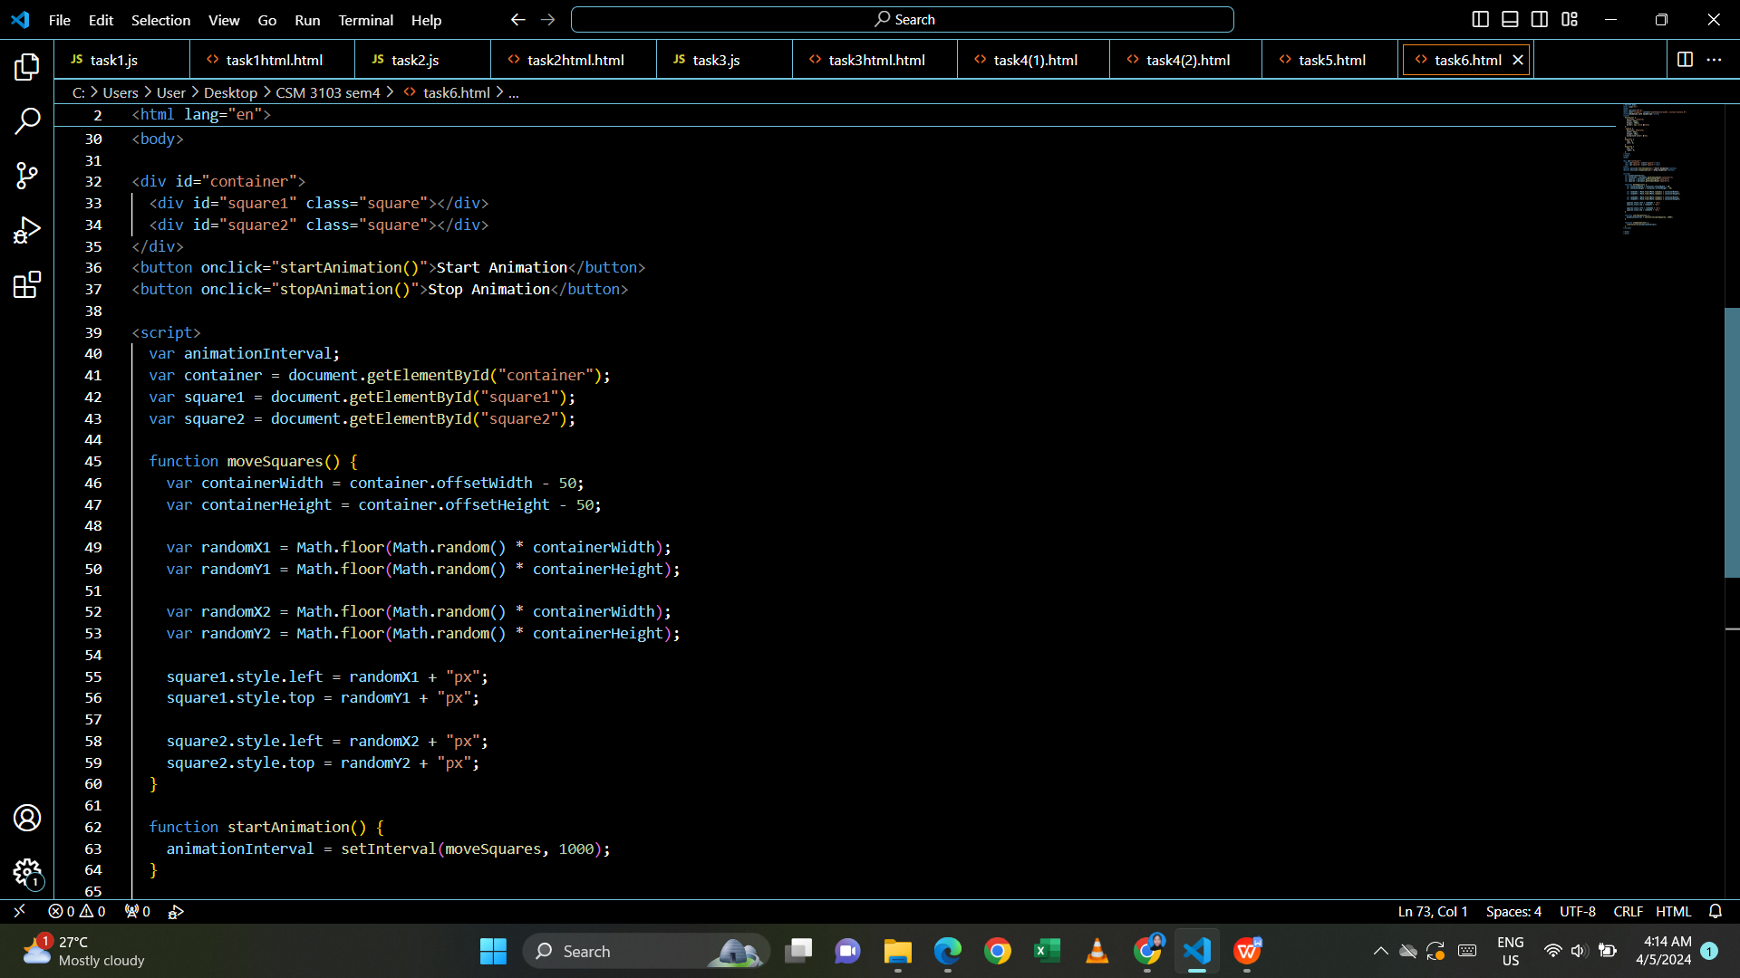

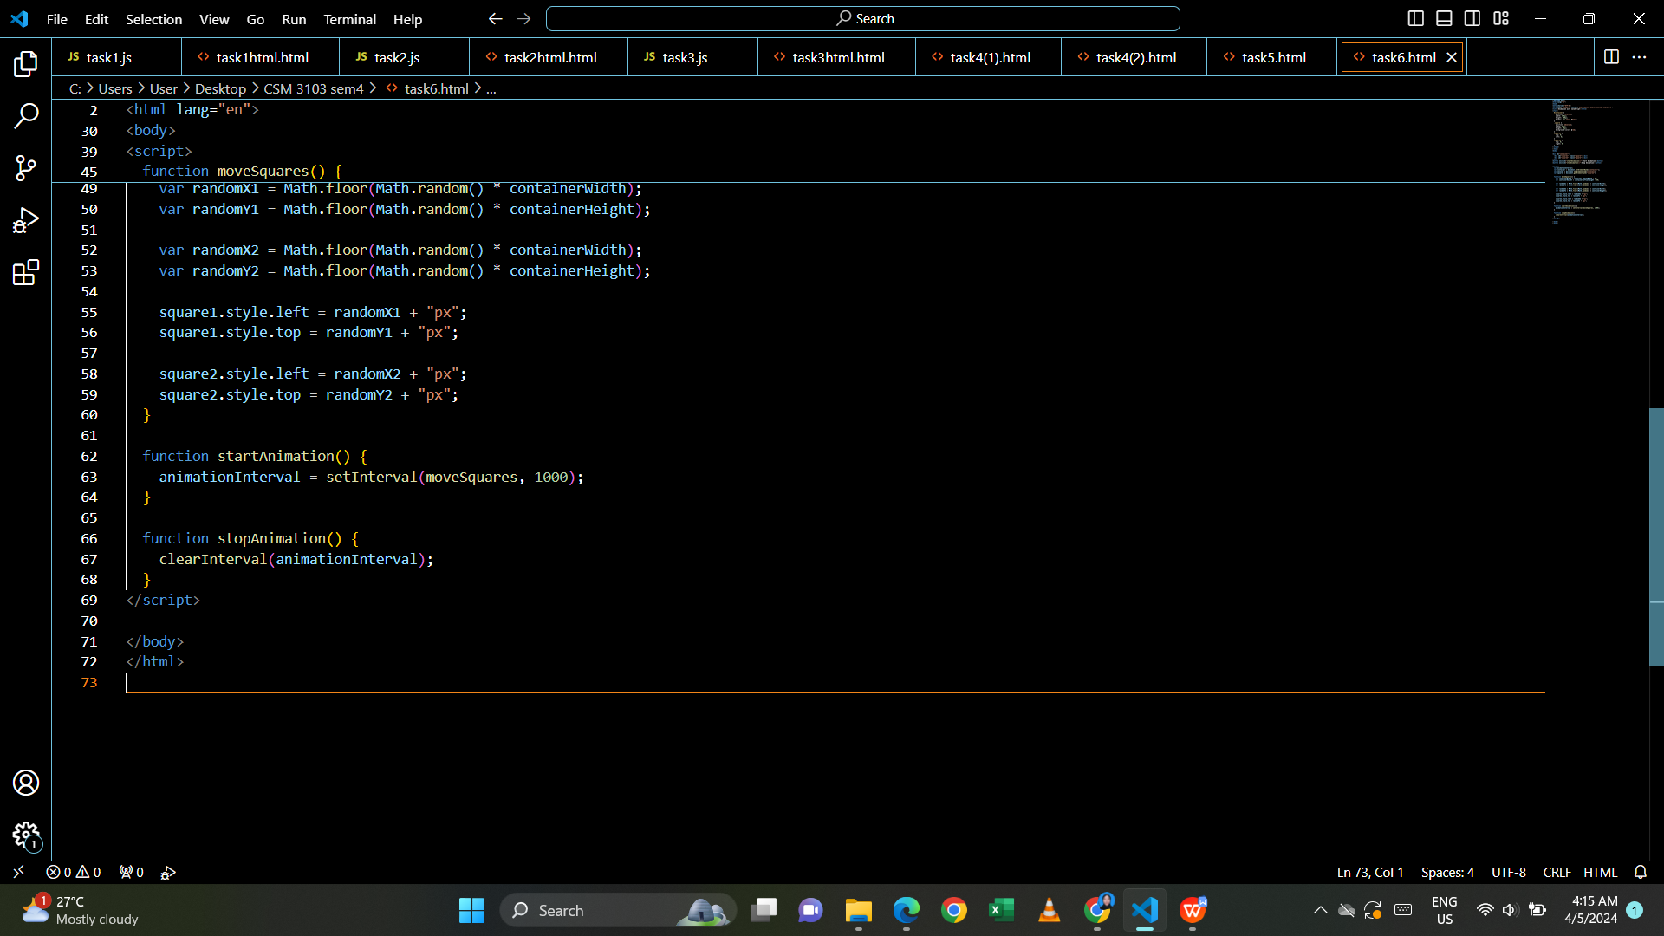

Output:

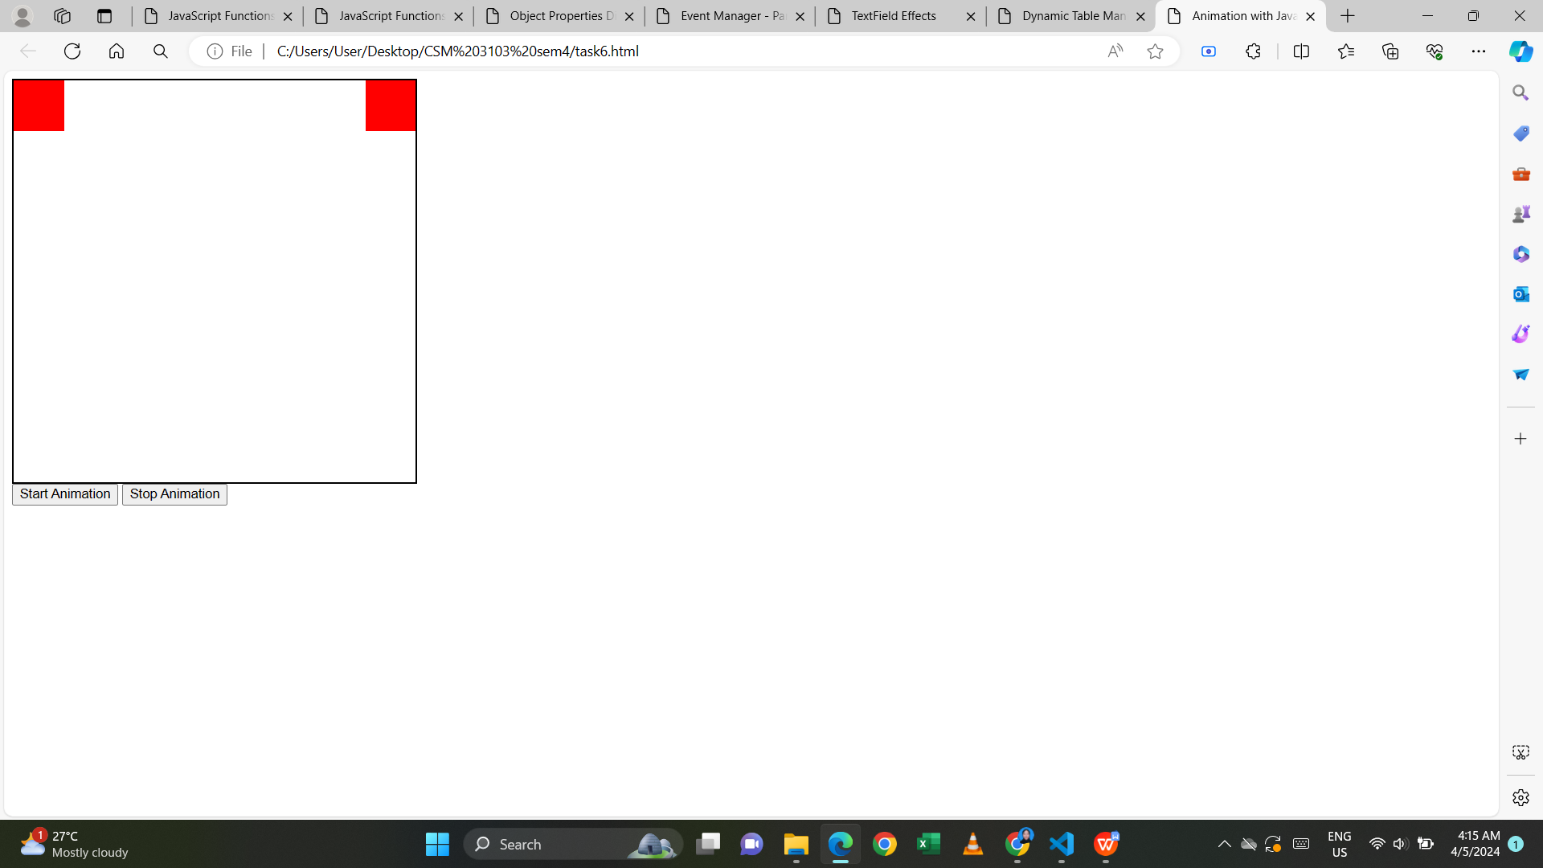

- start animation

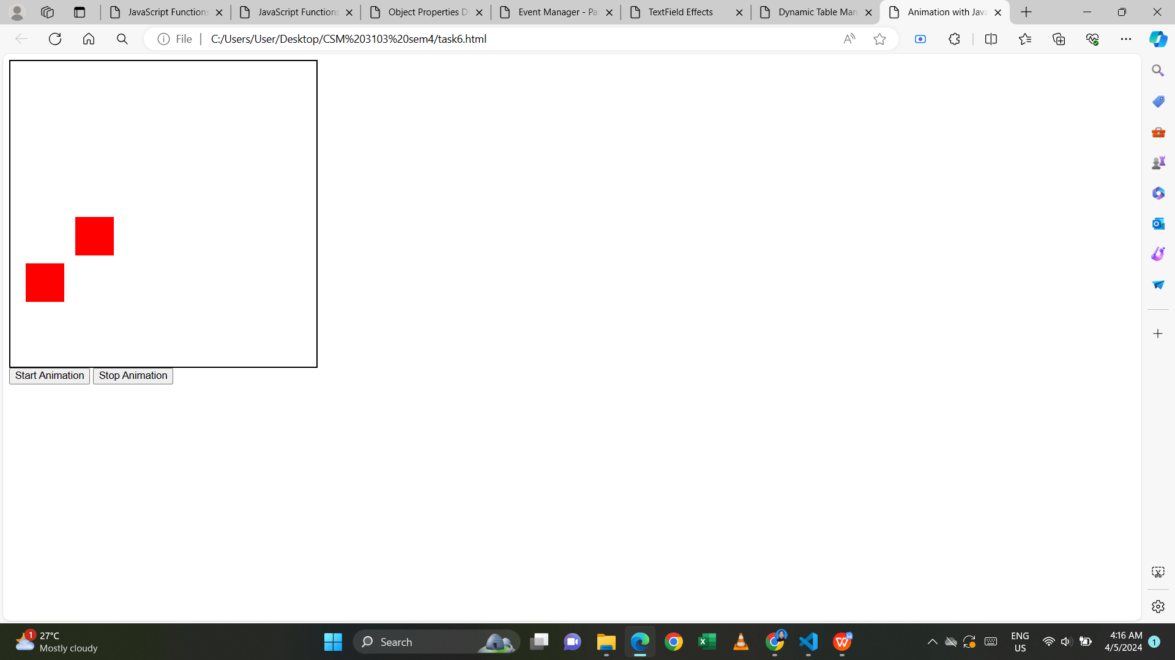

- stop animation

